COURIER MANAGEMENT SYSTEM (CMS)
USER STORY
Courier and logistics companies often struggle to efficiently manage shipments and deliveries due to reliance on manual processes and disconnected systems. The absence of a centralized shipment tracking mechanism makes it difficult to monitor parcel movement in real time, resulting in delayed delivery updates and poor visibility for customers. Delivery agent assignments are performed manually, increasing the chances of scheduling conflicts and operational delays. Furthermore, the lack of automated notifications prevents timely communication with customers, while the absence of performance analytics limits managerial insight into operational efficiency. Managing multiple branches becomes complex without an integrated platform, leading to coordination issues across locations. Collectively, these challenges result in customer dissatisfaction, reduced productivity, operational inefficiencies, and ultimately revenue loss for the organization.

1. INTRODUCTION

1.1 Project Overview
Courier and logistics companies face challenges in efficiently managing shipments and deliveries due to manual operations and disconnected systems. These issues lead to delayed updates, poor customer visibility, and operational inefficiencies.
The Courier Management System (CMS) is a Salesforce-based cloud solution that centralizes shipment booking, tracking, delivery agent assignment, automated status updates, billing, and analytics. The system improves operational efficiency, enhances customer satisfaction, and provides real-time business insights.

1.2 Purpose
The purpose of the Courier Management System is to provide a centralized platform for managing courier operations. The system is designed around Salesforce and brings together customer information, shipment records, delivery agents, branches, delivery updates, invoices, reports, and dashboards.
The platform reduces dependency on disconnected manual records and supports consistent data management. It also provides a structured workflow from shipment booking to delivery reporting. By using Salesforce objects, validation rules, flows, profiles, roles, and dashboards, the system supports both operational users and management.

2. IDEATION PHASE

2.1 Problem Statement

PS-1: Branch Manager
Branch managers require visibility into shipments, delivery agents, branch-level performance, delayed deliveries, and revenue-related information. Manual registers and spreadsheets make it difficult to obtain current information and coordinate delivery activities.

PS-2: Customer
Customers need timely shipment information and better visibility into parcel movement. When updates are handled manually, customers may not receive information at the expected time, reducing confidence in the delivery process.

Stakeholder | Problem | Need
Branch Manager | Manual tracking and agent assignment | Centralized shipment and agent visibility
Customer | Delayed or limited delivery updates | Reliable shipment status information

2.2 Empathy Map Canvas
The empathy map captures the experience of a Branch Manager who works with shipment and delivery operations. It helps identify practical concerns, expectations, pain points, and desired outcomes.
Area | Branch Manager Perspective
Think & Feel | Needs accurate shipment information, smooth coordination, and confidence that deliveries are being handled correctly.
Hear | Receives customer questions, delivery-agent updates, and operational instructions.
See | Shipment records, branch activities, delivery statuses, pending work, and performance information.
Say & Do | Assigns agents, checks delivery progress, handles exceptions, reviews reports, and supports customers.
Pain | Manual data entry, delayed updates, scheduling conflicts, disconnected records, and limited analytics.
Gain | Centralized data, automated status updates, faster coordination, reports, dashboards, and improved visibility.
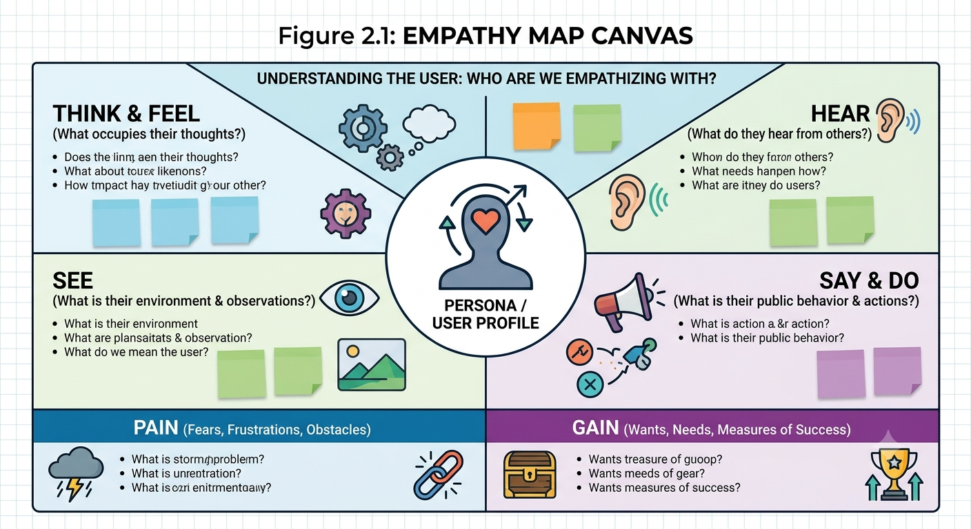

During ideation, several approaches were considered for managing courier operations. The alternatives were compared according to their ability to centralize information, automate activities, provide visibility, and scale across branches.
Idea | Description | Observation
Manual Registers | Paper-based shipment and delivery records. | Low automation and difficult to search or share.
Spreadsheet Tracking | Shipment information stored in spreadsheets. | Better than paper but still dependent on manual updates.
Standalone Portal | A dedicated portal for courier operations. | Can provide digital access but requires separate development and maintenance.
Salesforce CRM | Cloud-based objects, automation, security, reports, and dashboards. | Supports centralized records, workflow automation, scalability, and real-time visibility.

Final Selected Solution
Salesforce CRM is selected in the reference design because it provides an integrated platform for data management, automation, security, reporting, and dashboards. The solution can support multiple branches while maintaining a structured relationship between customers, shipments, agents, updates, and invoices.
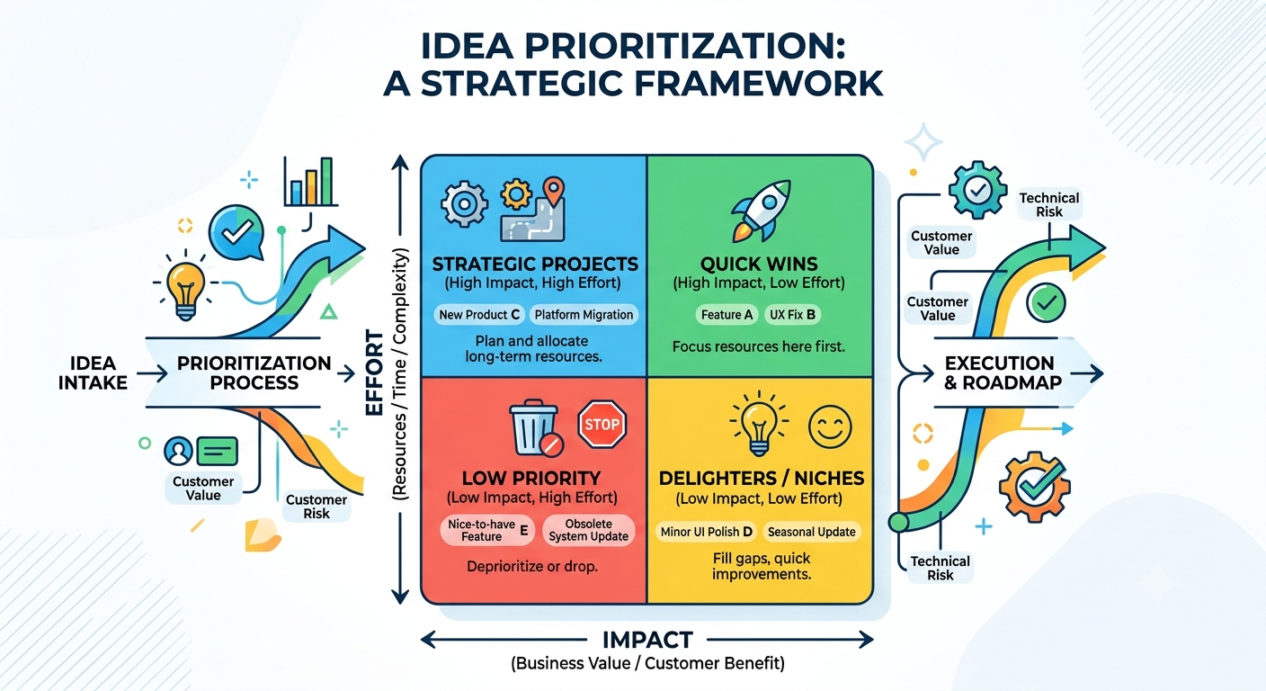
Figure 2.2 Idea Prioritization

3. REQUIREMENT ANALYSIS PHASE

3.1 Customer Journey Map
The customer journey follows the courier lifecycle from booking through reporting. Each stage represents a set of activities and information that must be maintained consistently.
Stage | Main Activity | System Information
Booking | Customer requests shipment service. | Customer details and shipment request.
Shipment Creation | Shipment record is created. | Tracking number, addresses, weight, price, type.
Agent Assignment | Delivery agent is assigned. | Assigned agent and branch relationship.
Transit | Shipment moves through the delivery process. | Current shipment status.
Delivery Update | Delivery event is recorded. | Status, date, remarks.
Invoice | Billing information is maintained. | Invoice number, amount, payment status.
Reporting | Management reviews operational data. | Shipment, agent, branch and revenue reports.
The journey map provides a direct connection between business activities and Salesforce records. It also helps identify where validation, automation, and reporting are required.
Figure 3.1: Customer Journey Map
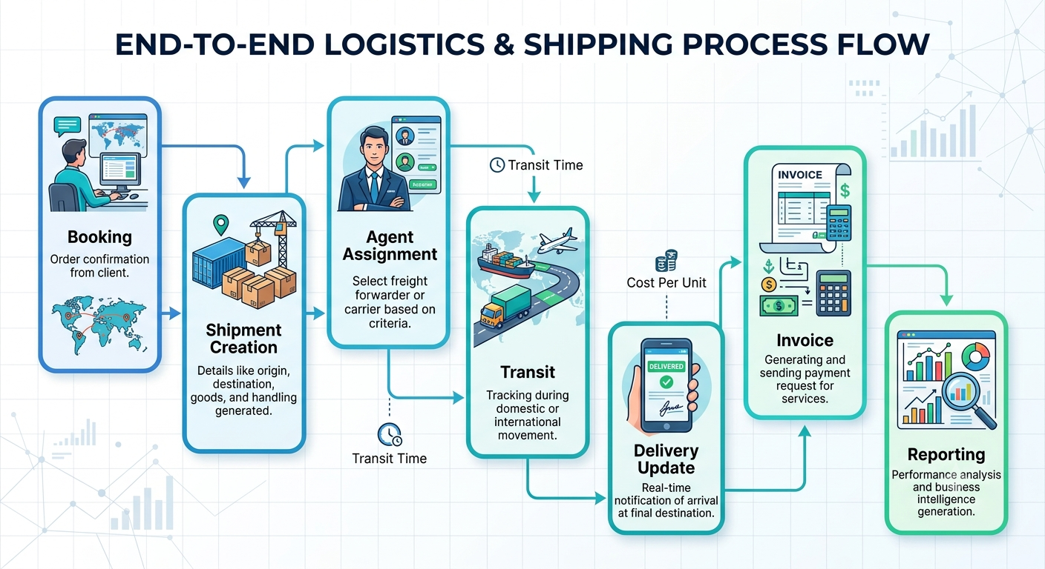

3.2 Solution Requirements – Functional Requirements
Functional requirements define the operations that the Courier Management System must support. These requirements are implemented through Salesforce objects, fields, relationships, flows, profiles, roles, reports, and dashboards.
Requirement | Description
Customer Management | Create and maintain customer information including name, email, phone, address, location, customer type, and active status.
Shipment Booking | Create shipment records containing tracking number, customer, source, destination, weight, price, status, expected date, assigned agent, and shipment type.
Delivery Agent Assignment | Associate a shipment with an available delivery agent and maintain the agent's branch relationship.
Real-Time Status Updates | Record delivery updates and use automation to update the related shipment status.
Invoice Generation | Maintain invoice details related to shipments, including amount, invoice date, and payment status.
Reports & Dashboards | Provide operational and management visibility through shipment, customer, agent, branch, and revenue reporting.

Functional Workflow
- Customer information is maintained in Customer__c.
- A shipment is created in Shipment__c and linked to the customer.
- A delivery agent is assigned to the shipment.
- Delivery_Update__c records changes in delivery status.
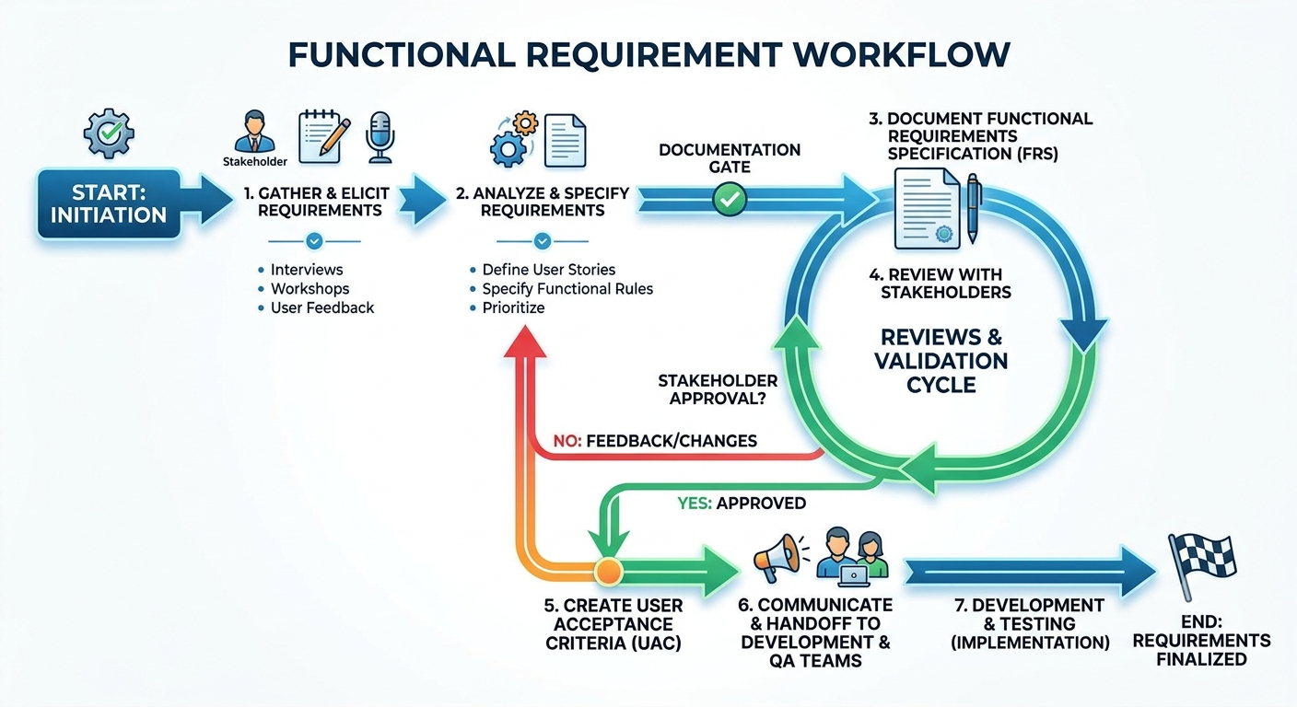
- The Salesforce Flow updates the related shipment status.Invoice__c stores billing information.

3.2 Solution Requirements – Non-Functional Requirements
Requirement | Expected Quality
Usability | The interface should allow users to access relevant records and activities with clear navigation.
Security | Access should be controlled using profiles, roles, object permissions, and tab visibility.
Reliability | Records and automated status updates should behave consistently during normal operations.
Performance | Common record access, flow actions, reports, and dashboards should provide practical response times.
Availability | The cloud-based Salesforce platform should support access for authorized users.
Scalability | The design should allow additional branches, customers, shipments, agents, and reports without changing the basic architecture.

Requirement Traceability
The requirements are connected to the later configuration milestones. Customer and shipment requirements are represented by objects and fields; data-quality requirements are represented by validation rules; status automation is represented by a record-triggered flow; access requirements are represented by profiles and roles; and management visibility is represented by reports and dashboards.
Requirement Area | Configuration Area
Customer and Shipment Data | Objects, Fields & Relationships
Data Quality | Validation Rules
Status Automation | Salesforce Flow
Navigation | Tabs and Lightning App
Access Control | Profiles and Roles
Management Insight | Reports and Dashboards

3.3 Data Flow Diagram
The data flow begins with customer input and proceeds through shipment creation, validation, agent assignment, delivery updates, invoice handling, and reporting.
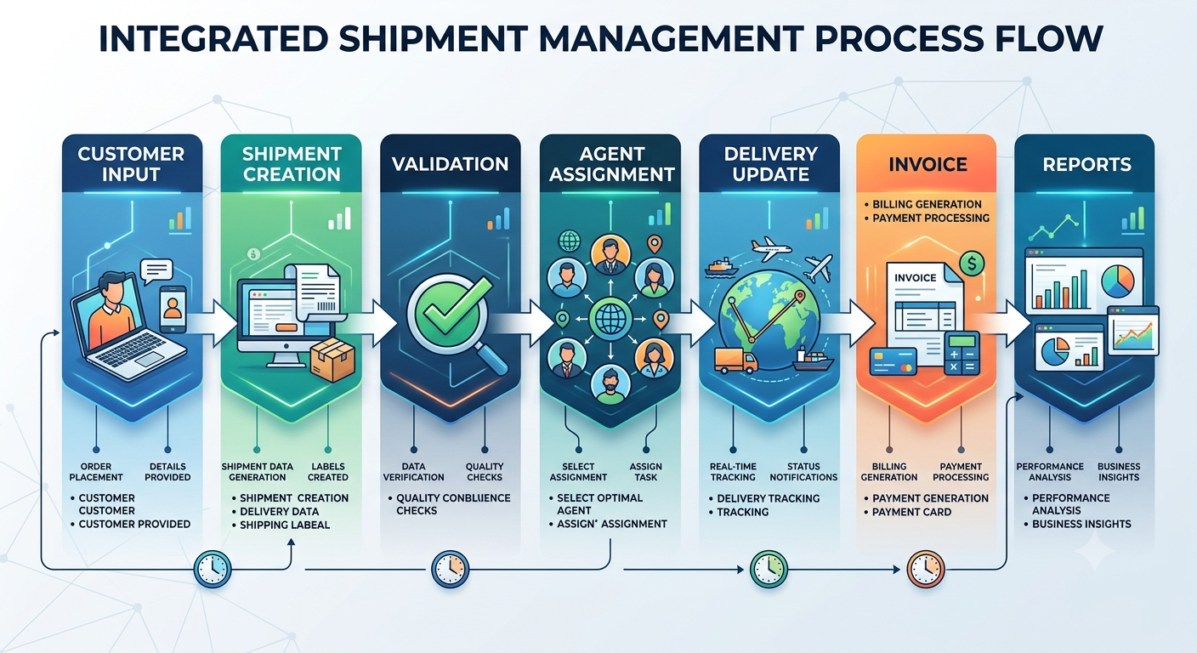
Flow Step | Input | Output
Customer Input | Customer and shipment request | Validated request data
Shipment Creation | Validated request | Shipment record
Validation | Shipment/customer fields | Accepted record or validation message
Agent Assignment | Shipment and agent information | Assigned shipment
Delivery Update | Delivery event | Updated delivery record
Invoice | Shipment billing information | Invoice record
Reports | Salesforce records | Operational and management insights

3.4 Technology Stack
Component | Technology
UI | Salesforce Lightning
Logic | Salesforce Flows
Database | Salesforce Objects
Automation | Validation Rules / Flows
Security | Profiles / Roles
Reporting | Reports & Dashboards

4. PROJECT DESIGN PHASE

4.1 Problem–Solution Fit
The proposed design maps the operational problems identified during ideation to Salesforce capabilities. Manual shipment records are replaced by centralized objects, manual status propagation is supported by Flow, access is controlled by profiles and roles, and operational information is summarized through reports and dashboards.
Problem | Salesforce-Oriented Solution
Disconnected shipment records | Centralized Salesforce objects
Manual status updates | Record-triggered Flow
Difficult agent coordination | Delivery Agent and Shipment relationships
Limited branch visibility | Branch records and reporting
Weak data quality | Validation Rules
Limited management insight | Reports and Dashboards

4.2 Proposed Solution
Area | Design
Problem | Manual and disconnected courier operations.
Solution | Salesforce-based centralized Courier Management System.
Innovation | Automation of shipment status updates and structured operational reporting.
Impact | Improved data visibility, consistency, and coordination.
Business Model | Cloud-based operational management using Salesforce capabilities.
Scalability | Additional records, users, branches, and reports can be accommodated within the design.

4.3 Solution Architecture
The solution architecture connects the main business entities and automation components. Customer information is associated with shipments. Shipments are associated with delivery agents, while agents belong to branches. Delivery updates and invoices are linked to shipments. Flows automate status changes, while reports and dashboards summarize operational information.
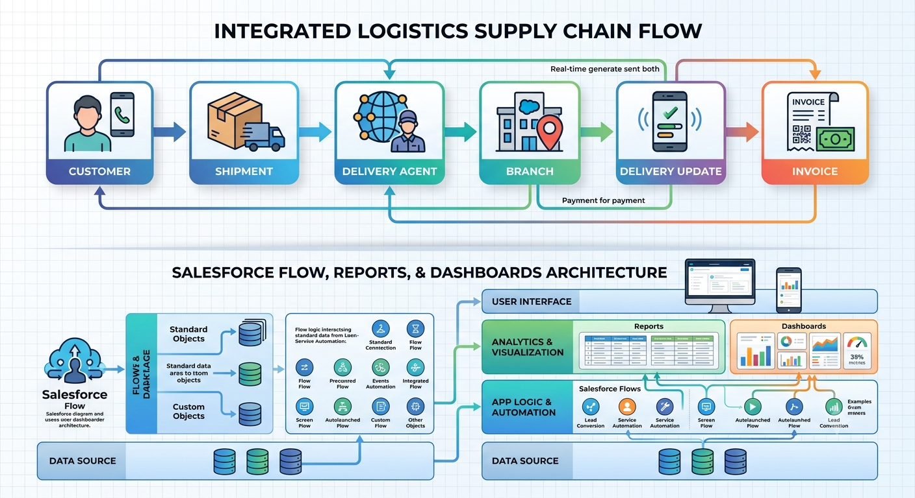
Component | Role
Customer | Stores customer identity and contact information.
Shipment | Stores parcel and delivery information.
Delivery Agent | Stores agent information and branch association.
Branch | Represents operational branch information.
Delivery Update | Stores status changes and remarks.
Invoice | Stores billing information linked to shipments.
Flows | Automate related record updates.
Reports | Present filtered and grouped data.
Dashboards | Provide visual summaries.

5. PROJECT PLANNING & SCHEDULING

Agile Methodology
The project follows an Agile-oriented approach in which the system is divided into manageable features and implementation activities. Work is organized into epics, user stories, story points, and sprints. Each sprint focuses on a group of related configuration tasks and produces a visible increment.

Epics
- Customer and Shipment Management
- Delivery Operations
- Data Quality and Automation
- Security and Access
- Reporting and Dashboard

User Stories
ID | User Story | Story Points
USN-1 | As a user, I want to create customer records so that customer information is centralized. | 3
USN-2 | As a user, I want to create shipments so that parcels can be tracked. | 5
USN-3 | As a manager, I want to assign delivery agents so that shipments can be managed. | 5
USN-4 | As a user, I want validation rules so that incorrect data is prevented. | 5
USN-5 | As a user, I want delivery updates to change shipment status automatically. | 8
USN-6 | As an administrator, I want profiles and roles so that access is controlled. | 5
USN-7 | As a manager, I want reports so that operational performance can be reviewed. | 5
USN-8 | As a manager, I want dashboards so that key information is visible quickly. | 5

5. PROJECT PLANNING & SCHEDULING – Sprint Execution

Sprint Execution
Sprint execution divides the configuration work into short, reviewable units. Activities are prioritized according to dependency: objects and fields are established before layouts and automation; access configuration follows the data model; reports and dashboards are configured after meaningful records and report types are available.
Sprint | Main Activities | Points | Duration
Sprint 1 | Requirements, objects, basic tabs | 13 | 1 week
Sprint 2 | Fields, relationships, validation | 18 | 1 week
Sprint 3 | Page layouts, Flow, Lightning App | 18 | 1 week
Sprint 4 | Profiles, roles, users | 13 | 1 week
Sprint 5 | Reports, dashboards, testing | 13 | 1 week

Velocity
Velocity represents the amount of planned story work completed during a sprint. It is used as a planning reference rather than as a quality measure. The sprint tracker can be updated during actual project execution.

Sprint | Planned Points | Completed Points | Observation
Sprint 1 | 13 | 13 | Foundation completed
Sprint 2 | 18 | 18 | Data configuration completed
Sprint 3 | 18 | 18 | Automation and application completed
Sprint 4 | 13 | 13 | Access structure completed
Sprint 5 | 13 | 13 | Reporting and testing completed

5. PROJECT PLANNING & SCHEDULING – Product Backlog

Product Backlog
Priority | ID | Feature | Acceptance Focus
High | USN-1 | Customer Management | Customer record can be created and maintained.
High | USN-2 | Shipment Management | Shipment details and tracking information can be stored.
High | USN-3 | Agent Assignment | Shipment can be associated with an agent.
High | USN-4 | Validation | Invalid values are prevented by configured rules.
High | USN-5 | Status Automation | Delivery update changes shipment status.
Medium | USN-6 | Security | Profiles and roles control access.
Medium | USN-7 | Reports | Operational reports provide grouped information.
Medium | USN-8 | Dashboard | Dashboard displays shipment, agent, and branch information.

Sprint Tracker
Sprint | Start | End | Focus
Sprint 1 | Week 1 | Week 1 | Objects and Tabs
Sprint 2 | Week 2 | Week 2 | Fields and Validation
Sprint 3 | Week 3 | Week 3 | Layouts and Flow
Sprint 4 | Week 4 | Week 4 | App, Profiles, Roles, Users
Sprint 5 | Week 5 | Week 5 | Reports, Dashboard, Testing

6. PROJECT DEVELOPMENT PHASE
The development phase begins with the Salesforce environment and continues through data model creation, navigation, validation, automation, security, reporting, and testing.
6. PROJECT DEVELOPMENT PHASE – Salesforce Account
Introduction to Salesforce
Salesforce provides a cloud-based environment in which the Courier Management System can be configured using objects, fields, relationships, automation, security settings, reports, and dashboards. The development process uses a Salesforce Developer environment for configuration and testing.

Activity 1: Creating Developer Account
Creating a Developer Org in Salesforce
- Go to https://developer.salesforce.com/signup
- On the Sign Up form, enter the following details:
  - First Name & Last Name
  - Email
  - Job Title: Developer
  - Company: College Name
  - Country: India
- Create a username and password.
- Check the details entered in the registration form.
- Click on Sign Me Up.
- Check the registered email for the Salesforce account activation link.
Figure 6.1: Salesforce Developer Account Creation
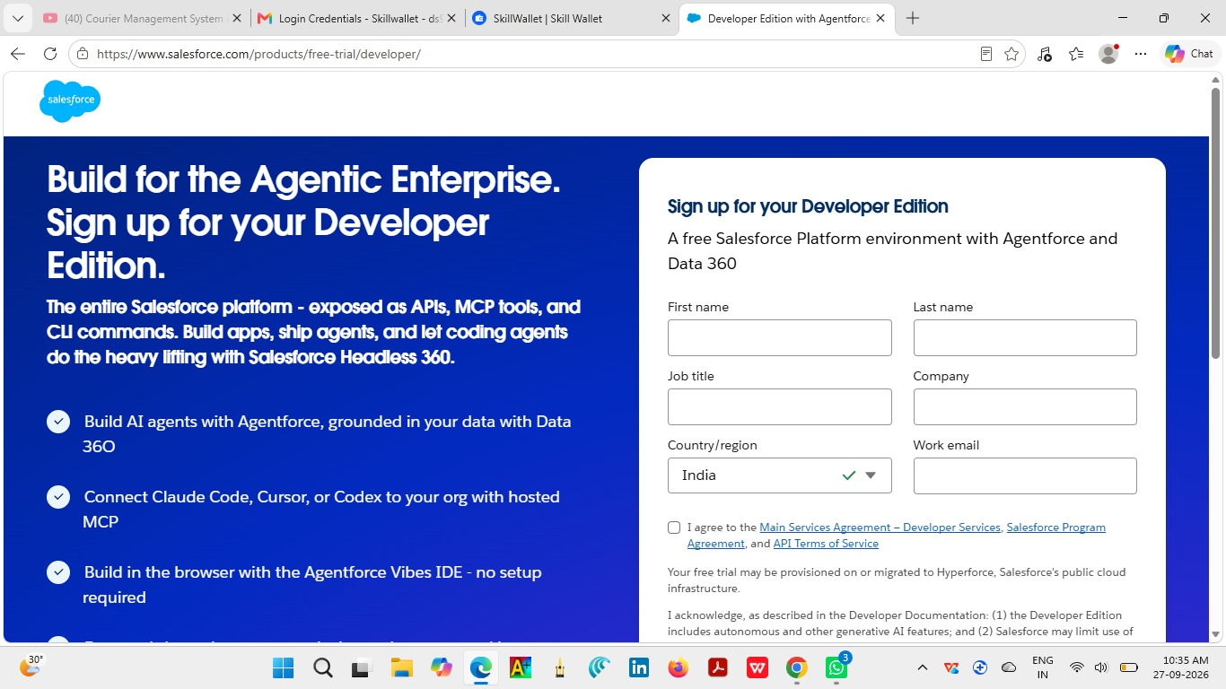

6. PROJECT DEVELOPMENT PHASE – Account Activation

Activity 2: Account Activation
Activating the Salesforce Developer Account
- Go to the inbox of the email that you used while signing up.
- Click on Verify Account to activate your Salesforce account. The email may take 10–30 minutes, and sometimes up to 2 hours.
- Click on Verify Account in the email.
- Enter a password and answer the security question.
- Click on Change Password.
- You will be redirected to the Salesforce Setup page.

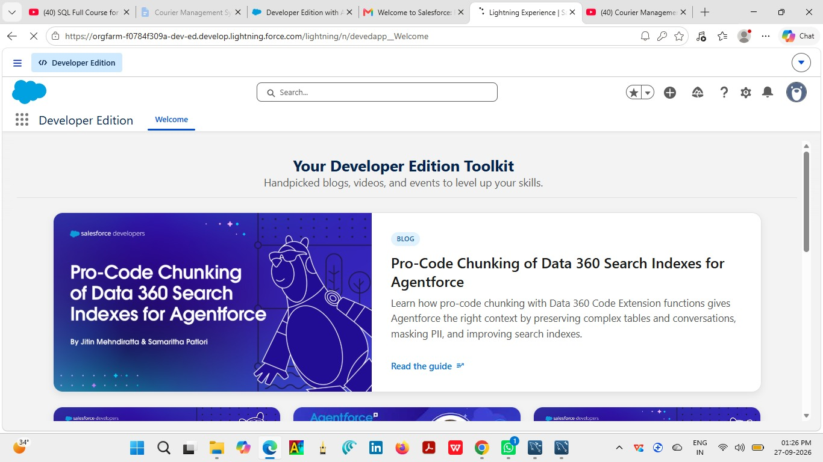
Figure 6.2: Salesforce Lightning Development Environment

Development Readiness
After activation, the environment can be used to create custom objects, fields, relationships, validation rules, flows, tabs, apps, profiles, roles, users, reports, and dashboards.
MILESTONE 2 – OBJECT

Customer__c
Purpose: Stores customer identity and contact information.

Object Settings
The custom object Customer__c is created in Salesforce to represent a major business entity in the Courier Management System. The object name is used consistently in relationships, layouts, validation rules, and reporting.
Creation Procedure

Open Setup and navigate to Object Manager.
- Select the option to create a Custom Object.
- Enter the object label as Customer.
- Configure the object name and record settings as required.
- Enable the object for the intended Salesforce interface.
- Save the object.
- Open the newly created object and verify that it is available for further configuration.

Expected Result
The Customer__c object is available in Object Manager and can be configured with fields, relationships, tabs, layouts, and permissions.

Fields / Related Information
Customer Name, Email, Phone, Address, Customer Type, City, State, Pincode, Is Active.
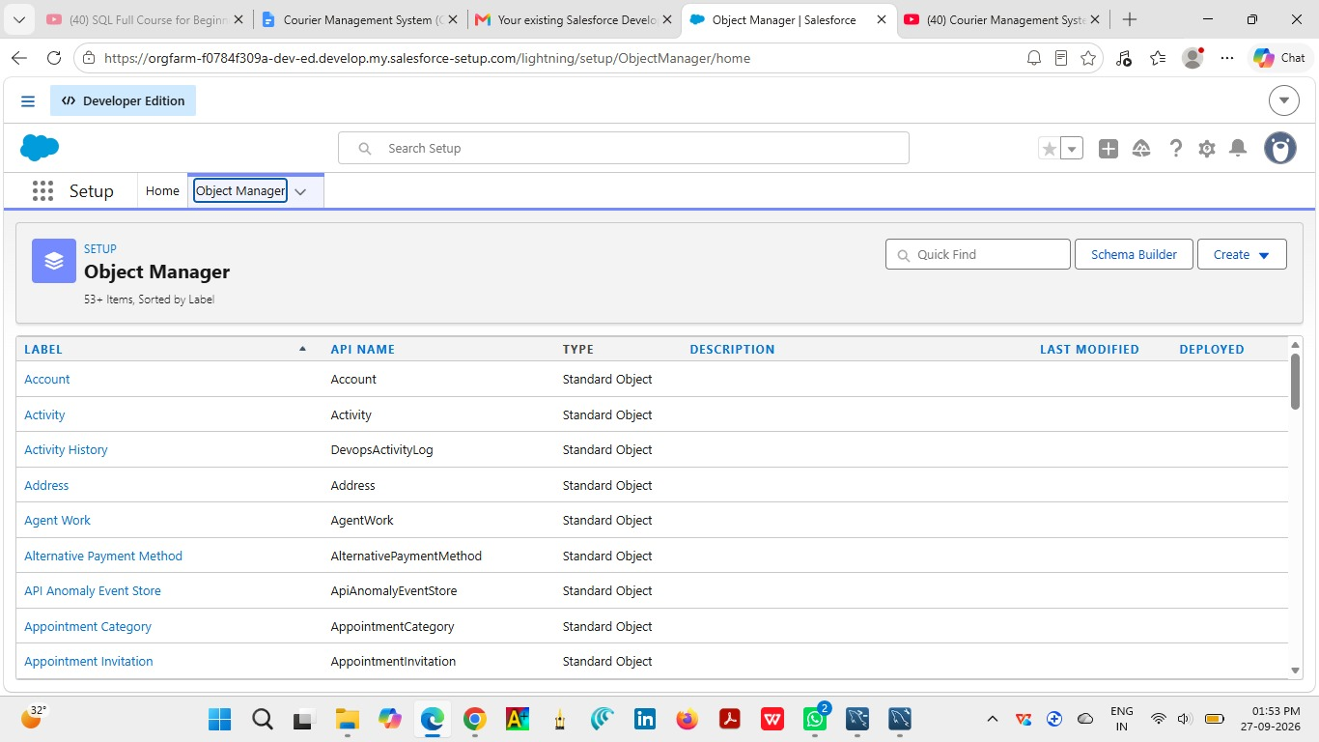
Figure 1.1: Customer__c Configuration
MILESTONE 2 – OBJECT

Shipment__c
Purpose: Stores shipment and delivery information.

Object Settings
The custom object Shipment__c is created in Salesforce to represent a major business entity in the Courier Management System. The object name is used consistently in relationships, layouts, validation rules, and reporting.

Creation Procedure
- Open Setup and navigate to Object Manager.
- Select the option to create a Custom Object.
- Enter the object label as Shipment.
- Configure the object name and record settings as required.
- Enable the object for the intended Salesforce interface.
- Save the object.
- Open the newly created object and verify that it is available for further configuration.

Expected Result
The Shipment__c object is available in Object Manager and can be configured with fields, relationships, tabs, layouts, and permissions.

Fields / Related Information
Tracking Number, Customer, Source Address, Destination Address, Weight, Price, Status, Expected Date, Assigned Agent, Shipment Type.

Figure 2.1: Shipment__c Configuration

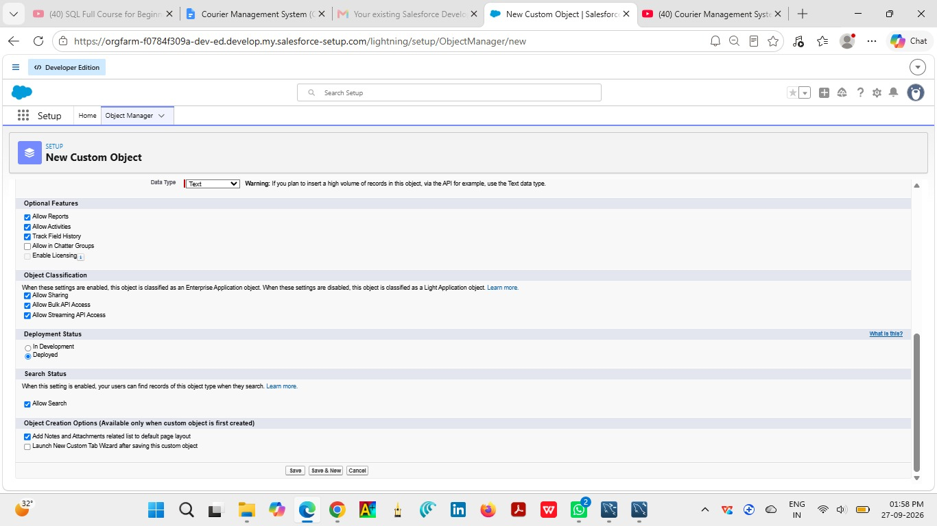
MILESTONE 2 – OBJECT

Delivery_Agent__c
Purpose: Stores delivery agent details and branch association.

Object Settings
The custom object Delivery_Agent__c is created in Salesforce to represent a major business entity in the Courier Management System. The object name is used consistently in relationships, layouts, validation rules, and reporting.

Creation Procedure
- Open Setup and navigate to Object Manager.
- Select the option to create a Custom Object.
- Enter the object label as Delivery_Agent.
- Configure the object name and record settings as required.
- Enable the object for the intended Salesforce interface.
- Save the object.
- Open the newly created object and verify that it is available for further configuration.

Expected Result
The Delivery_Agent__c object is available in Object Manager and can be configured with fields, relationships, tabs, layouts, and permissions.

Fields / Related Information
Agent Name, Email, Phone, Branch, Status, Joining Date.

Figure 3.1: Delivery_Agent__c Configuration
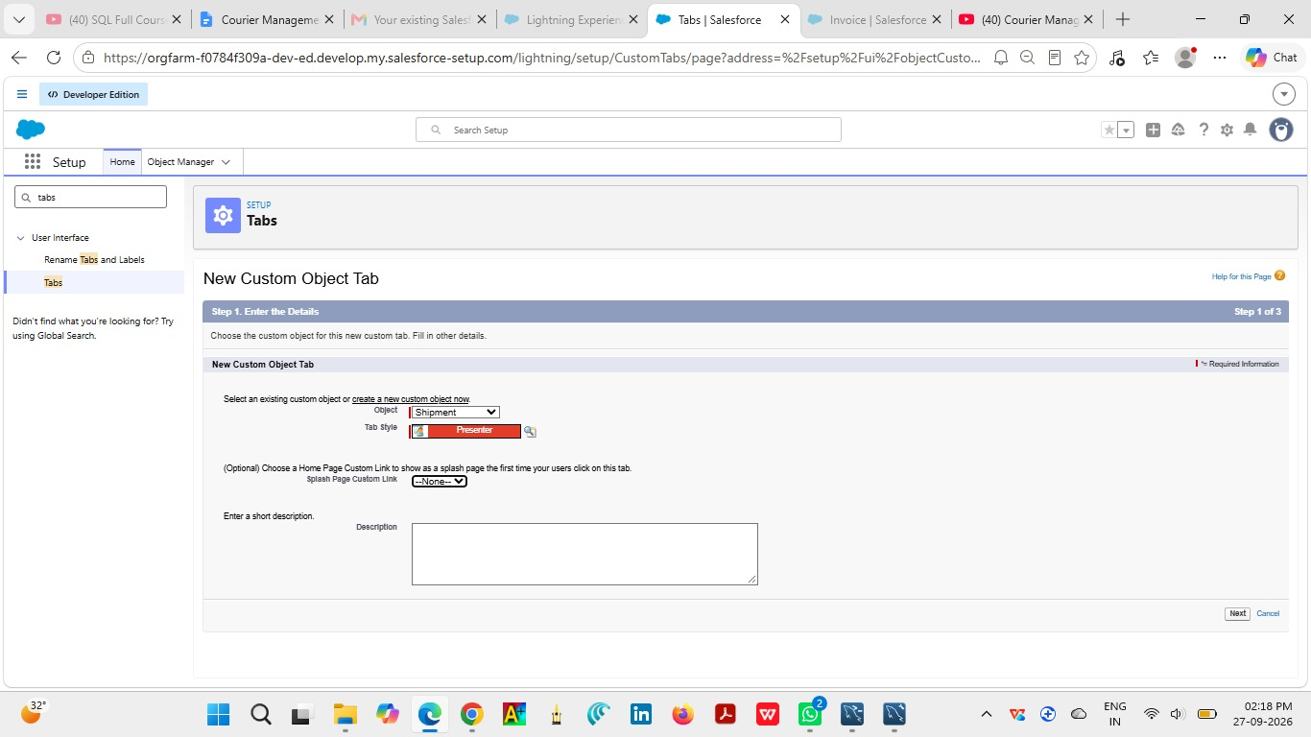
MILESTONE 2 – OBJECT

Branch__c
Purpose: Stores courier branch information.

Object Settings
The custom object Branch__c is created in Salesforce to represent a major business entity in the Courier Management System. The object name is used consistently in relationships, layouts, validation rules, and reporting.

Creation Procedure
- Open Setup and navigate to Object Manager.
- Select the option to create a Custom Object.
- Enter the object label as Branch.
- Configure the object name and record settings as required.
- Enable the object for the intended Salesforce interface.
- Save the object.
- Open the newly created object and verify that it is available for further configuration.

Expected Result
The Branch__c object is available in Object Manager and can be configured with fields, relationships, tabs, layouts, and permissions.

Fields / Related Information
Branch Name, Branch Code, City, State, Manager Name.

MILESTONE 2 – OBJECT

Delivery_Update__c
Purpose: Stores status updates associated with a shipment.

Object Settings
The custom object Delivery_Update__c is created in Salesforce to represent a major business entity in the Courier Management System. The object name is used consistently in relationships, layouts, validation rules, and reporting.

Creation Procedure
- Open Setup and navigate to Object Manager.
- Select the option to create a Custom Object.
- Enter the object label as Delivery_Update.
- Configure the object name and record settings as required.
- Enable the object for the intended Salesforce interface.
- Save the object.
- Open the newly created object and verify that it is available for further configuration.

Expected Result
The Delivery_Update__c object is available in Object Manager and can be configured with fields, relationships, tabs, layouts, and permissions.

Fields / Related Information
Update Number, Shipment, Status, Update Date, Remarks.

MILESTONE 2 – OBJECT

Invoice__c
Purpose: Stores billing information associated with a shipment.

Object Settings
The custom object Invoice__c is created in Salesforce to represent a major business entity in the Courier Management System. The object name is used consistently in relationships, layouts, validation rules, and reporting.

Creation Procedure
- Open Setup and navigate to Object Manager.
- Select the option to create a Custom Object.
- Enter the object label as Invoice.
- Configure the object name and record settings as required.
- Enable the object for the intended Salesforce interface.
- Save the object.
- Open the newly created object and verify that it is available for further configuration.

Expected Result
The Invoice__c object is available in Object Manager and can be configured with fields, relationships, tabs, layouts, and permissions.

Fields / Related Information
Invoice Number, Shipment, Amount, Invoice Date, Payment Status.
MILESTONE 3 – TABS
Salesforce Tabs provide navigation access to objects from the application interface. Custom tabs make the configured Courier Management System records easy to open and manage.

Customer Tab
- Open Setup and navigate to Tabs.
- Select the appropriate custom object.
- Create a new custom tab for the Customer object.
- Choose an appropriate tab style and save the configuration.
- Verify the tab in the application navigation.

Shipment Tab
- Open Setup and navigate to Tabs.
- Select the appropriate custom object.
- Create a new custom tab for the Shipment object.
- Choose an appropriate tab style and save the configuration.
- Verify the tab in the application navigation.

MILESTONE 3 – TABS
Salesforce Tabs provide navigation access to objects from the application interface. Custom tabs make the configured Courier Management System records easy to open and manage.

Delivery Agent Tab
- Open Setup and navigate to Tabs.
- Select the appropriate custom object.
- Create a new custom tab for the Delivery Agent object.
- Choose an appropriate tab style and save the configuration.
- Verify the tab in the application navigation.

Branch Tab
- Open Setup and navigate to Tabs.
- Select the appropriate custom object.
- Create a new custom tab for the Branch object.
- Choose an appropriate tab style and save the configuration.
- Verify the tab in the application navigation.

MILESTONE 3 – TABS
Salesforce Tabs provide navigation access to objects from the application interface. Custom tabs make the configured Courier Management System records easy to open and manage.

Delivery Update Tab
- Open Setup and navigate to Tabs.
- Select the appropriate custom object.
- Create a new custom tab for the Delivery Update object.
- Choose an appropriate tab style and save the configuration.
- Verify the tab in the application navigation.

Invoice Tab
- Open Setup and navigate to Tabs.
- Select the appropriate custom object.
- Create a new custom tab for the Invoice object.
- Choose an appropriate tab style and save the configuration.
- Verify the tab in the application navigation.

MILESTONE 4 – FIELDS & RELATIONSHIPS
What are fields ?
Fields in Salesforce represent what the columns represent in relational databases. It can store data values which are required for a particular object in a record.

Customer Fields
Fields define the information stored in the Customer object. Each field is configured with an appropriate data type and is displayed through the corresponding page layout.
Field | Purpose | Suggested Type
Customer Name | Customer's name | Text / Name
Email | Customer email address | Email
Phone | Customer contact number | Phone
Address | Customer address | Text/Area
Customer Type | Category of customer | Picklist
City | Customer city | Text
State | Customer state | Text
Pincode | Customer postal code | Text
Is Active | Indicates active customer | Checkbox

Field Creation Procedure
1. Customer Name (Text Field)
- Go to Setup → Object Manager → Customer__c.
- Click Fields & Relationships → New.
- Select Text → Next.
- Enter Field Label: Customer Name.
- Enter the required field length.
- Click Next → Next → Save.
2. Email (Email Field)
- Go to Setup → Object Manager → Customer__c.
- Click Fields & Relationships → New.
- Select Email → Next.
- Enter Field Label: Email.
- Check the Required box.
- Click Next → Next → Save.
3. Phone (Phone Field)
- Go to Setup → Object Manager → Customer__c.
- Click Fields & Relationships → New.
- Select Phone → Next.
- Enter Field Label: Phone.
- Check the Required box.
- Click Next → Next → Save.
4. Address (Text Area Field)
- Go to Setup → Object Manager → Customer__c.
- Click Fields & Relationships → New.
- Select Text Area → Next.
- Enter Field Label: Address.
- Enter the required field length.
- Click Next → Next → Save.
5. Customer Type (Picklist Field)
- Go to Setup → Object Manager → Customer__c.
- Click Fields & Relationships → New.
- Select Picklist → Next.
- Enter Field Label: Customer Type.
- Enter the required picklist values.
- Click Next → Next → Save.
6. City (Text Field)
- Go to Setup → Object Manager → Customer__c.
- Click Fields & Relationships → New.
- Select Text → Next.
- Enter Field Label: City.
- Enter the required field length.
- Click Next → Next → Save.
7. State (Text Field)
- Go to Setup → Object Manager → Customer__c.
- Click Fields & Relationships → New.
- Select Text → Next.
- Enter Field Label: State.
- Enter the required field length.
- Click Next → Next → Save.
8. Pincode (Number Field)
- Go to Setup → Object Manager → Customer__c.
- Click Fields & Relationships → New.
- Select Number → Next.
- Enter Field Label: Pincode.
- Enter the required field length and decimal places.
- Click Next → Next → Save.
9. Is Active (Checkbox Field)
- Go to Setup → Object Manager → Customer__c.
- Click Fields & Relationships → New.
- Select Checkbox → Next.
- Enter Field Label: Is Active.
- Set the default value as required.
- Click Next → Next → Save.

MILESTONE 4 – FIELDS & RELATIONSHIPS

Shipment Fields
Fields define the information stored in the Shipment object. Each field is configured with an appropriate data type and is displayed through the corresponding page layout.
Field | Purpose | Suggested Type
Tracking Number | Unique shipment reference | Text
Customer | Customer relationship | Lookup
Source Address | Shipment origin | Text/Area
Destination Address | Shipment destination | Text/Area
Weight | Shipment weight | Number
Price | Shipment price | Currency
Status | Current shipment state | Picklist
Expected Date | Expected delivery date | Date
Assigned Agent | Delivery agent relationship | Lookup
Shipment Type | Type/category of shipment | Picklist

Field Creation Procedure
1. Tracking Number (Text Field)
- Go to Setup → Object Manager → Shipment__c.
- Click Fields & Relationships → New.
- Select Text → Next.
- Enter Field Label: Tracking Number.
- Enter the required field length.
- Click Next → Next → Save.
2. Customer (Lookup Relationship Field)
- Go to Setup → Object Manager → Shipment__c.
- Click Fields & Relationships → New.
- Select Lookup Relationship → Next.
- Select Customer__c as the related object.
- Enter Field Label: Customer.
- Click Next → Next → Save.
3. Source Address (Text Area Field)
- Go to Setup → Object Manager → Shipment__c.
- Click Fields & Relationships → New.
- Select Text Area → Next.
- Enter Field Label: Source Address.
- Enter the required field length.
- Click Next → Next → Save.
4. Destination Address (Text Area Field)
- Go to Setup → Object Manager → Shipment__c.
- Click Fields & Relationships → New.
- Select Text Area → Next.
- Enter Field Label: Destination Address.
- Enter the required field length.
- Click Next → Next → Save.
5. Weight (Number Field)
- Go to Setup → Object Manager → Shipment__c.
- Click Fields & Relationships → New.
- Select Number → Next.
- Enter Field Label: Weight.
- Enter the required field length and decimal places.
- Click Next → Next → Save.
6. Price (Currency Field)
- Go to Setup → Object Manager → Shipment__c.
- Click Fields & Relationships → New.
- Select Currency → Next.
- Enter Field Label: Price.
- Enter the required field length and decimal places.
- Click Next → Next → Save.
7. Status (Picklist Field)
- Go to Setup → Object Manager → Shipment__c.
- Click Fields & Relationships → New.
- Select Picklist → Next.
- Enter Field Label: Status.
- Enter the required picklist values.
- Click Next → Next → Save.
8. Expected Date (Date Field)
- Go to Setup → Object Manager → Shipment__c.
- Click Fields & Relationships → New.
- Select Date → Next.
- Enter Field Label: Expected Date.
- Set the required field settings.
- Click Next → Next → Save.
9. Assigned Agent (Lookup Relationship Field)
- Go to Setup → Object Manager → Shipment__c.
- Click Fields & Relationships → New.
- Select Lookup Relationship → Next.
- Select Delivery_Agent__c as the related object.
- Enter Field Label: Assigned Agent.
- Click Next → Next → Save.
10. Shipment Type (Picklist Field)
- Go to Setup → Object Manager → Shipment__c.
- Click Fields & Relationships → New.
- Select Picklist → Next.
- Enter Field Label: Shipment Type.
- Enter the required picklist values.
- Click Next → Next → Save.

MILESTONE 4 – FIELDS & RELATIONSHIPS

Delivery Agent Fields
Fields define the information stored in the Delivery Agent object. Each field is configured with an appropriate data type and is displayed through the corresponding page layout.
Field | Purpose | Suggested Type
Agent Name | Agent identity | Text/Name
Email | Agent email | Email
Phone | Agent phone | Phone
Branch | Agent branch relationship | Lookup
Status | Agent availability/status | Picklist
Joining Date | Date joined | Date

Field Creation Procedure
1. Agent Name (Text Field)
- Go to Setup → Object Manager → Delivery_Agent__c.
- Click Fields & Relationships → New.
- Select Text → Next.
- Enter Field Label: Agent Name.
- Enter the required field length.
- Click Next → Next → Save.
2. Email (Email Field)
- Go to Setup → Object Manager → Delivery_Agent__c.
- Click Fields & Relationships → New.
- Select Email → Next.
- Enter Field Label: Email.
- Check the Required box.
- Click Next → Next → Save.
3. Phone (Phone Field)
- Go to Setup → Object Manager → Delivery_Agent__c.
- Click Fields & Relationships → New.
- Select Phone → Next.
- Enter Field Label: Phone.
- Check the Required box.
- Click Next → Next → Save.
4. Branch (Lookup Relationship Field)
- Go to Setup → Object Manager → Delivery_Agent__c.
- Click Fields & Relationships → New.
- Select Lookup Relationship → Next.
- Select Branch__c as the related object.
- Enter Field Label: Branch.
- Click Next → Next → Save.
5. Status (Picklist Field)
- Go to Setup → Object Manager → Delivery_Agent__c.
- Click Fields & Relationships → New.
- Select Picklist → Next.
- Enter Field Label: Status.
- Enter the required picklist values.
- Click Next → Next → Save.
6. Joining Date (Date Field)
- Go to Setup → Object Manager → Delivery_Agent__c.
- Click Fields & Relationships → New.
- Select Date → Next.
- Enter Field Label: Joining Date.
- Set the required field settings.
- Click Next → Next → Save.

MILESTONE 4 – FIELDS & RELATIONSHIPS

Branch Fields
Fields define the information stored in the Branch object. Each field is configured with an appropriate data type and is displayed through the corresponding page layout.
Field | Purpose | Suggested Type
Branch Name | Branch identity | Text/Name
Branch Code | Unique branch reference | Text
City | Branch city | Text
State | Branch state | Text
Manager Name | Branch manager | Text

Field Creation Procedure

1. Branch Name (Text Field)
- Go to Setup → Object Manager → Branch__c.
- Click Fields & Relationships → New.
- Select Text → Next.
- Enter Field Label: Branch Name.
- Enter the required field length.
- Click Next → Next → Save.
2. Branch Code (Text Field)
- Go to Setup → Object Manager → Branch__c.
- Click Fields & Relationships → New.
- Select Text → Next.
- Enter Field Label: Branch Code.
- Enter the required field length.
- Click Next → Next → Save.
3. City (Text Field)
- Go to Setup → Object Manager → Branch__c.
- Click Fields & Relationships → New.
- Select Text → Next.
- Enter Field Label: City.
- Enter the required field length.
- Click Next → Next → Save.
4. State (Text Field)
- Go to Setup → Object Manager → Branch__c.
- Click Fields & Relationships → New.
- Select Text → Next.
- Enter Field Label: State.
- Enter the required field length.
- Click Next → Next → Save.
5. Manager Name (Text Field)
- Go to Setup → Object Manager → Branch__c.
- Click Fields & Relationships → New.
- Select Text → Next.
- Enter Field Label: Manager Name.
- Enter the required field length.
- Click Next → Next → Save.

MILESTONE 4 – FIELDS & RELATIONSHIPS

Delivery Update Fields
Fields define the information stored in the Delivery Update object. Each field is configured with an appropriate data type and is displayed through the corresponding page layout.
Field | Purpose | Suggested Type
Update Number | Update reference | Auto Number/Text
Shipment | Shipment relationship | Master-Detail
Status | Delivery status | Picklist
Update Date | Date of update | Date
Remarks | Additional update information | Long Text

Field Creation Procedure

Field Creation Procedure
1. Update Number (Auto Number Field)
- Go to Setup → Object Manager → Delivery_Update__c.
- Click Fields & Relationships → New.
- Select Auto Number → Next.
- Enter Field Label: Update Number.
- Enter the required display format and starting number.
- Click Next → Next → Save.
2. Shipment (Master-Detail Relationship Field)
- Go to Setup → Object Manager → Delivery_Update__c.
- Click Fields & Relationships → New.
- Select Master-Detail Relationship → Next.
- Select Shipment__c as the related object.
- Enter Field Label: Shipment.
- Click Next → Next → Save.
3. Status (Picklist Field)
- Go to Setup → Object Manager → Delivery_Update__c.
- Click Fields & Relationships → New.
- Select Picklist → Next.
- Enter Field Label: Status.
- Enter the required picklist values.
- Click Next → Next → Save.
4. Update Date (Date Field)
- Go to Setup → Object Manager → Delivery_Update__c.
- Click Fields & Relationships → New.
- Select Date → Next.
- Enter Field Label: Update Date.
- Set the required field settings.
- Click Next → Next → Save.
5. Remarks (Text Area Field)
- Go to Setup → Object Manager → Delivery_Update__c.
- Click Fields & Relationships → New.
- Select Text Area → Next.
- Enter Field Label: Remarks.
- Enter the required field length.
- Click Next → Next → Save.

MILESTONE 4 – FIELDS & RELATIONSHIPS

Invoice Fields
Fields define the information stored in the Invoice object. Each field is configured with an appropriate data type and is displayed through the corresponding page layout.
Field | Purpose | Suggested Type
Invoice Number | Invoice reference | Auto Number/Text
Shipment | Shipment relationship | Lookup
Amount | Invoice amount | Currency
Invoice Date | Invoice date | Date
Payment Status | Payment state | Picklist

Field Creation Procedure

Field Creation Procedure
1. Invoice Number (Auto Number Field)
- Go to Setup → Object Manager → Invoice__c.
- Click Fields & Relationships → New.
- Select Auto Number → Next.
- Enter Field Label: Invoice Number.
- Enter the required display format and starting number.
- Click Next → Next → Save.
2. Shipment (Lookup Relationship Field)
- Go to Setup → Object Manager → Invoice__c.
- Click Fields & Relationships → New.
- Select Lookup Relationship → Next.
- Select Shipment__c as the related object.
- Enter Field Label: Shipment.
- Click Next → Next → Save.
3. Amount (Currency Field)
- Go to Setup → Object Manager → Invoice__c.
- Click Fields & Relationships → New.
- Select Currency → Next.
- Enter Field Label: Amount.
- Enter the required field length and decimal places.
- Click Next → Next → Save.
4. Invoice Date (Date Field)
- Go to Setup → Object Manager → Invoice__c.
- Click Fields & Relationships → New.
- Select Date → Next.
- Enter Field Label: Invoice Date.
- Set the required field settings.
- Click Next → Next → Save.
5. Payment Status (Picklist Field)
- Go to Setup → Object Manager → Invoice__c.
- Click Fields & Relationships → New.
- Select Picklist → Next.
- Enter Field Label: Payment Status.
- Enter the required picklist values.
- Click Next → Next → Save.

MILESTONE 4 – FIELDS & RELATIONSHIPS

Relationships and Data Model
Relationships connect the major Salesforce objects and allow related information to be accessed consistently.
Relationship | Type | Purpose
Customer → Shipment | Lookup | Associates a shipment with its customer.
Shipment → Delivery Agent | Lookup | Associates a shipment with an assigned agent.
Delivery Agent → Branch | Lookup | Associates an agent with a branch.
Delivery Update → Shipment | Master-Detail | Connects delivery updates directly to the shipment.
Invoice → Shipment | Lookup | Associates invoice information with the shipment.

MILESTONE 5 – VALIDATION RULES
Salesforce Validation Rules enforce data-quality conditions before a record is saved. The rules below follow the configuration specified for the Courier Management System.

Customer: Email Required
Item | Configuration
Rule Name | Email Required
Purpose | Prevents customer records without email.
Formula | ISBLANK(Email__c)
Error Message | Email is required.
Error Location | Field-level

Configuration Steps
- Open Object Manager and select the relevant object.
- Open Validation Rules and select New Rule.
- Enter the rule name: Email Required.
- Enter the formula exactly as configured for the rule.
- Enter the error message and error location.
- Save and activate the rule.
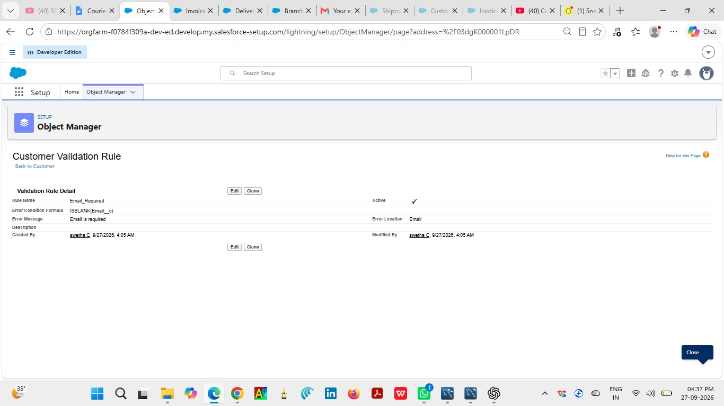
Customer: Phone 10 Digits
Item | Configuration
Rule Name | Phone 10 Digits
Purpose | Checks phone length.
Formula | LEN(Phone__c) <> 10
Error Message | Phone must contain 10 digits.
Error Location | Field-level

Configuration Steps
- Open Object Manager and select the relevant object.
- Open Validation Rules and select New Rule.
- Enter the rule name: Phone 10 Digits.
- Enter the formula exactly as configured for the rule.
- Enter the error message and error location.
- Save and activate the rule.

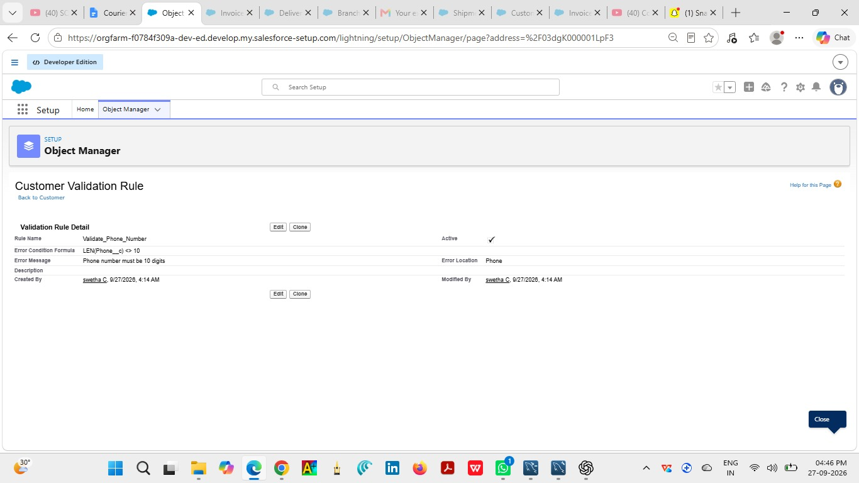

Customer: Pincode 6 Digits
Item | Configuration
Rule Name | Pincode 6 Digits
Purpose | Checks pincode length.
Formula | LEN(Pincode__c) <> 6
Error Message | Pincode must contain 6 digits.
Error Location | Field-level

Configuration Steps
- Open Object Manager and select the relevant object.
- Open Validation Rules and select New Rule.
- Enter the rule name: Pincode 6 Digits.
- Enter the formula exactly as configured for the rule.
- Enter the error message and error location.
- Save and activate the rule.
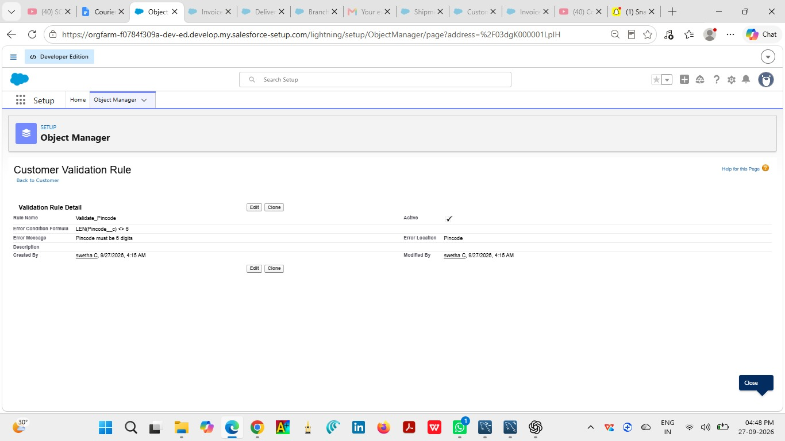

Shipment: Weight Must Be Greater Than Zero
Item | Configuration
Rule Name | Weight Must Be Greater Than Zero
Purpose | Prevents invalid weight.
Formula | Weight__c <= 0
Error Message | Weight must be greater than zero.
Error Location | Field-level

Configuration Steps
- Open Object Manager and select the relevant object.
- Open Validation Rules and select New Rule.
- Enter the rule name: Weight Must Be Greater Than Zero.
- Enter the formula exactly as configured for the rule.
- Enter the error message and error location.
- Save and activate the rule.
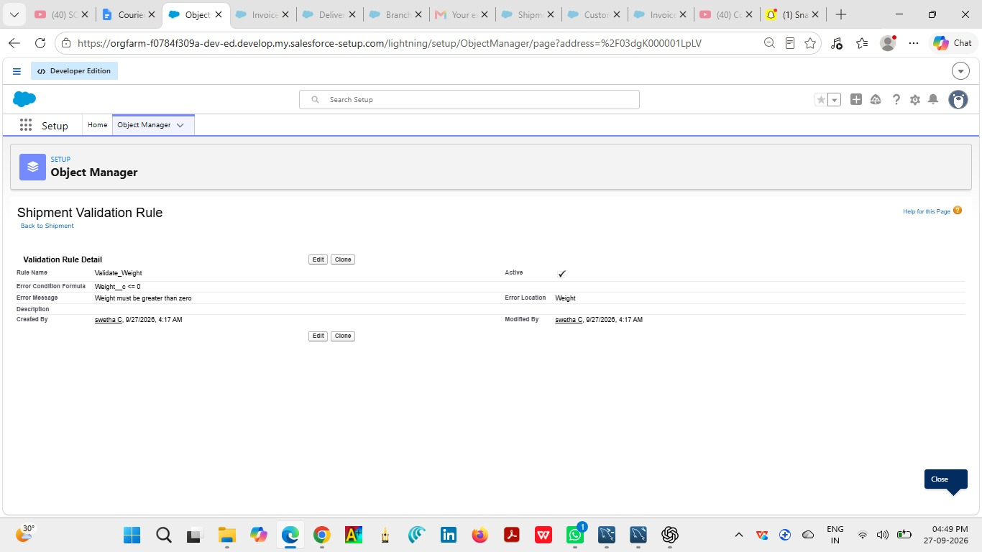

Shipment: Price Must Be Greater Than Zero
Item | Configuration
Rule Name | Price Must Be Greater Than Zero
Purpose | Prevents invalid price.
Formula | Price__c <= 0
Error Message | Price must be greater than zero.
Error Location | Field-level

Configuration Steps
- Open Object Manager and select the relevant object.
- Open Validation Rules and select New Rule.
- Enter the rule name: Price Must Be Greater Than Zero.
- Enter the formula exactly as configured for the rule.
- Enter the error message and error location.
- Save and activate the rule.
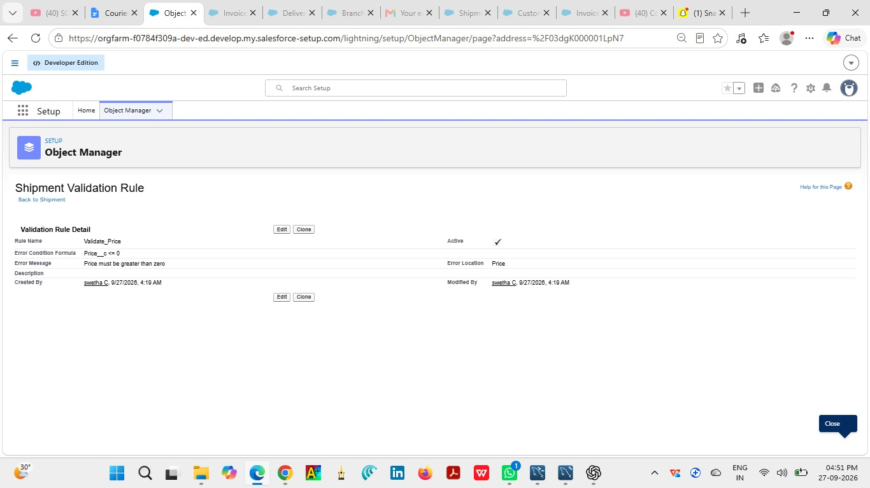

Shipment: Expected Date Cannot Be in the Past
Item | Configuration
Rule Name | Expected Date Cannot Be in the Past
Purpose | Checks expected delivery date.
Formula | Expected_Date__c < TODAY()
Error Message | Expected date cannot be in the past.
Error Location | Field-level

Configuration Steps
- Open Object Manager and select the relevant object.
- Open Validation Rules and select New Rule.
- Enter the rule name: Expected Date Cannot Be in the Past.
- Enter the formula exactly as configured for the rule.
- Enter the error message and error location.
- Save and activate the rule.

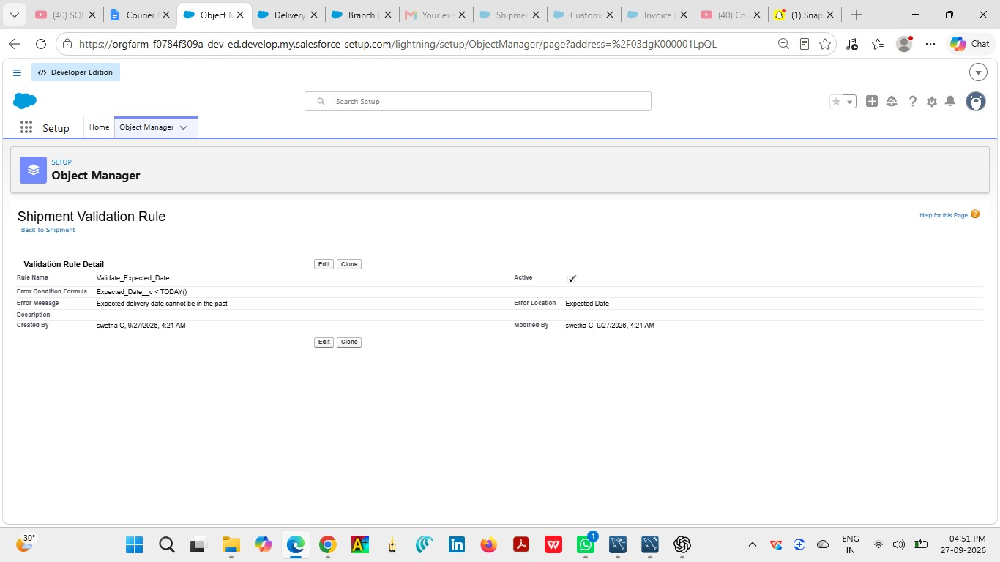
MILESTONE 5 – VALIDATION RULES
Salesforce Validation Rules enforce data-quality conditions before a record is saved. The rules below follow the configuration specified for the Courier Management System.

Branch: Branch Code Required
Item | Configuration
Rule Name | Branch Code Required
Purpose | Prevents missing branch code.
Formula | ISBLANK(Branch_Code__c)
Error Message | Branch Code is required.
Error Location | Field-level

Configuration Steps
- Open Object Manager and select the relevant object.
- Open Validation Rules and select New Rule.
- Enter the rule name: Branch Code Required.
- Enter the formula exactly as configured for the rule.
- Enter the error message and error location.
- Save and activate the rule.
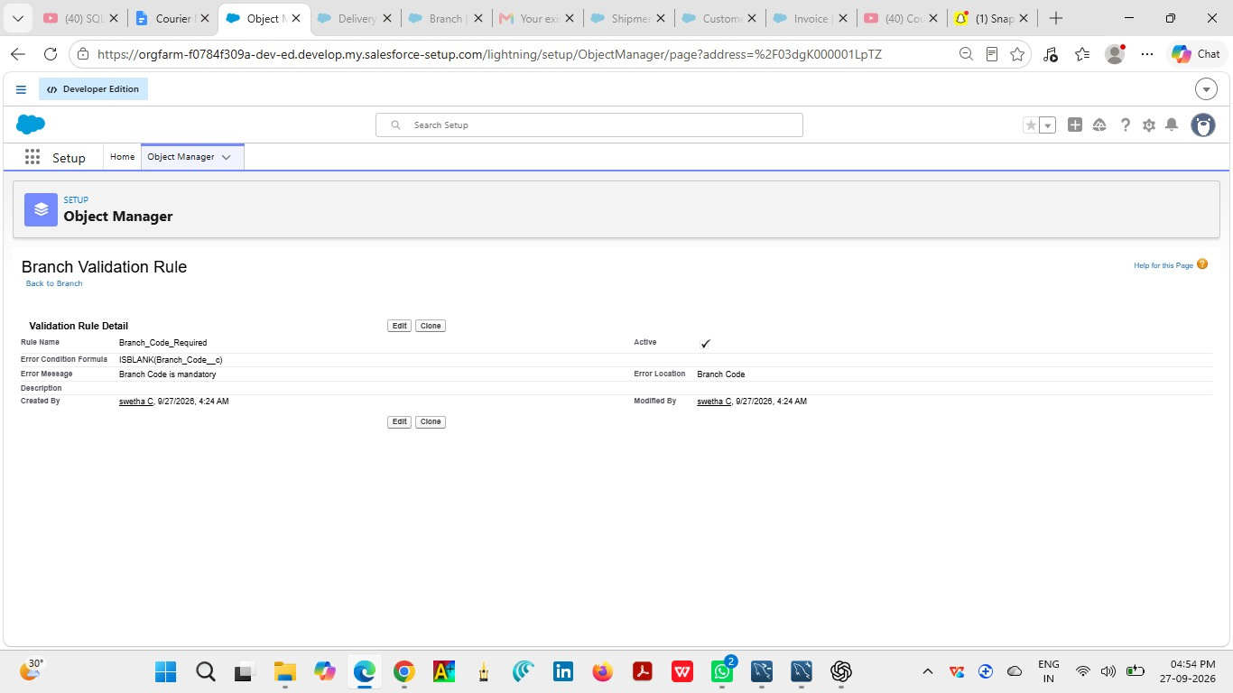

Delivery Update: Remarks Required When Shipment Is Delayed
Item | Configuration
Rule Name | Remarks Required When Shipment Is Delayed
Purpose | Requires explanation for delayed shipments.
Formula | AND(ISPICKVAL(Status__c, "Delayed"), ISBLANK(Remarks__c))
Error Message | Remarks are required when status is Delayed.
Error Location | Field-level

Configuration Steps
- Open Object Manager and select the relevant object.
- Open Validation Rules and select New Rule.
- Enter the rule name: Remarks Required When Shipment Is Delayed.
- Enter the formula exactly as configured for the rule.
- Enter the error message and error location.
- Save and activate the rule.

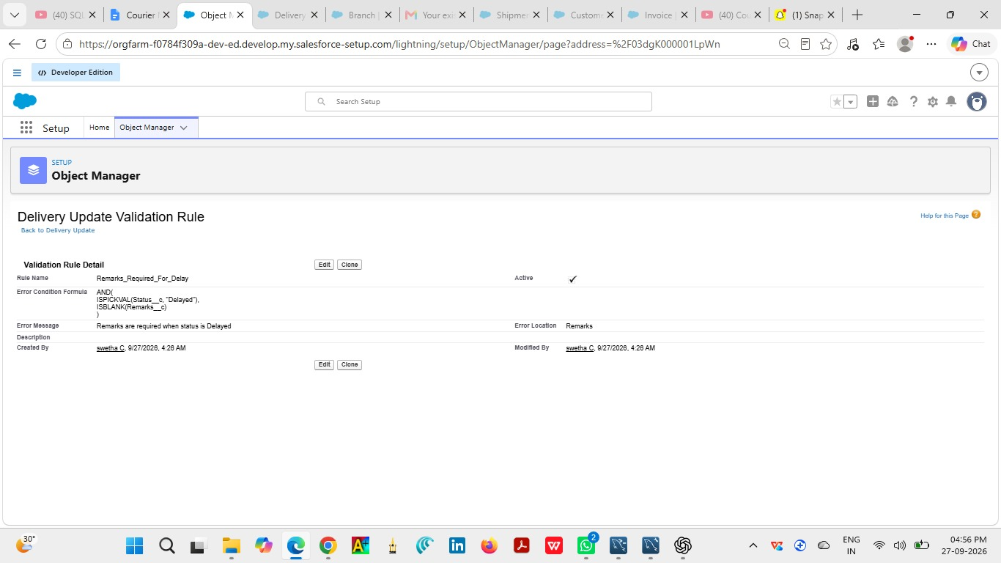

MILESTONE 6 – PAGE LAYOUTS

Customer Page Layout
The Customer page layout controls how the fields and related information are presented when a user opens a Customer record. A clear layout supports consistent data entry and review.

Layout Purpose
Organize the main Customer fields into a practical record page so that users can quickly enter, review, and maintain information.

Fields Displayed
Customer Name, Email, Phone, Address, Customer Type, City, State, Pincode, Is Active

Configuration Steps
- Open Object Manager.
- Select the relevant object.
- Open Page Layouts.
- Edit or create the layout.
- Arrange fields into logical sections.
- Save the layout and verify it on a record.

Expected Result
The Customer record displays its configured fields in a consistent and readable layout.

MILESTONE 6 – PAGE LAYOUTS

Shipment Page Layout
The Shipment page layout controls how the fields and related information are presented when a user opens a Shipment record. A clear layout supports consistent data entry and review.

Layout Purpose
Organize the main Shipment fields into a practical record page so that users can quickly enter, review, and maintain information.

Fields Displayed
Tracking Number, Customer, Source Address, Destination Address, Weight, Price, Status, Expected Date, Assigned Agent, Shipment Type

Configuration Steps
- Open Object Manager.
- Select the relevant object.
- Open Page Layouts.
- Edit or create the layout.
- Arrange fields into logical sections.
- Save the layout and verify it on a record.

Expected Result
The Shipment record displays its configured fields in a consistent and readable layout.

MILESTONE 6 – PAGE LAYOUTS

Delivery Agent Page Layout
The Delivery Agent page layout controls how the fields and related information are presented when a user opens a Delivery Agent record. A clear layout supports consistent data entry and review.

Layout Purpose
Organize the main Delivery Agent fields into a practical record page so that users can quickly enter, review, and maintain information.

Fields Displayed
Agent Name, Email, Phone, Branch, Status, Joining Date

Configuration Steps
- Open Object Manager.
- Select the relevant object.
- Open Page Layouts.
- Edit or create the layout.
- Arrange fields into logical sections.
- Save the layout and verify it on a record.

Expected Result
The Delivery Agent record displays its configured fields in a consistent and readable layout.

MILESTONE 6 – PAGE LAYOUTS

Branch Page Layout
The Branch page layout controls how the fields and related information are presented when a user opens a Branch record. A clear layout supports consistent data entry and review.

Layout Purpose
Organize the main Branch fields into a practical record page so that users can quickly enter, review, and maintain information.

Fields Displayed
Branch Name, Branch Code, City, State, Manager Name

Configuration Steps
- Open Object Manager.
- Select the relevant object.
- Open Page Layouts.
- Edit or create the layout.
- Arrange fields into logical sections.
- Save the layout and verify it on a record.

Expected Result
The Branch record displays its configured fields in a consistent and readable layout.

MILESTONE 6 – PAGE LAYOUTS

Delivery Update Page Layout
The Delivery Update page layout controls how the fields and related information are presented when a user opens a Delivery Update record. A clear layout supports consistent data entry and review.

Layout Purpose
Organize the main Delivery Update fields into a practical record page so that users can quickly enter, review, and maintain information.

Fields Displayed
Update Number, Shipment, Status, Update Date, Remarks

Configuration Steps
- Open Object Manager.
- Select the relevant object.
- Open Page Layouts.
- Edit or create the layout.
- Arrange fields into logical sections.
- Save the layout and verify it on a record.

Expected Result
The Delivery Update record displays its configured fields in a consistent and readable layout.

MILESTONE 6 – PAGE LAYOUTS

Invoice Page Layout
The Invoice page layout controls how the fields and related information are presented when a user opens a Invoice record. A clear layout supports consistent data entry and review.

Layout Purpose
Organize the main Invoice fields into a practical record page so that users can quickly enter, review, and maintain information.

Fields Displayed
Invoice Number, Shipment, Amount, Invoice Date, Payment Status

Configuration Steps
- Open Object Manager.
- Select the relevant object.
- Open Page Layouts.
- Edit or create the layout.
- Arrange fields into logical sections.
- Save the layout and verify it on a record.

Expected Result
The Invoice record displays its configured fields in a consistent and readable layout.

MILESTONE 7 – FLOWS

Auto_Update_Shipment_Status
The Flow automates shipment status synchronization. When a Delivery_Update__c record is created, the related Shipment__c record is updated with the delivery status stored in the new update.

Flow Logic
- Create a Record-Triggered Flow.
- Select Delivery_Update__c as the triggering object.
- Configure the flow to run when a record is created.
- Use the Start configuration for the record-triggered flow.
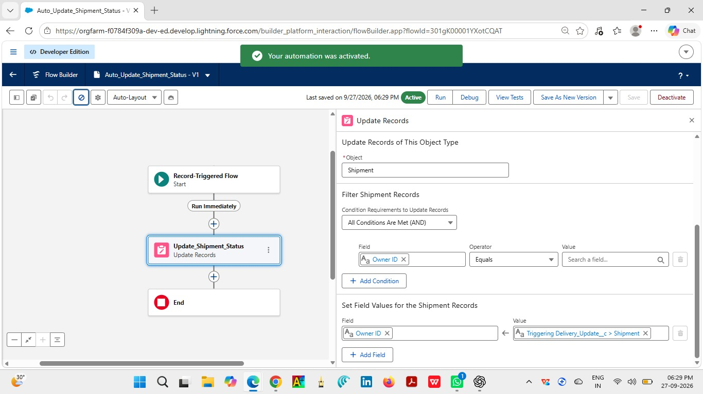

MILESTONE 7 – FLOWS

Auto_Update_Shipment_Status
The Flow automates shipment status synchronization. When a Delivery_Update__c record is created, the related Shipment__c record is updated with the delivery status stored in the new update.

Flow Logic
- Add an Update Records element.
- Select Shipment__c as the record to update.
- Match the Shipment Id with $Record.Shipment__c.
- Map Shipment Status to $Record.Status__c.

MILESTONE 7 – FLOWS

Auto_Update_Shipment_Status
The Flow automates shipment status synchronization. When a Delivery_Update__c record is created, the related Shipment__c record is updated with the delivery status stored in the new update.

- Save the flow with the name Auto_Update_Shipment_Status.
- Review the flow for configuration errors.
- Activate the flow.
- Create a Delivery Update record for testing.

MILESTONE 7 – FLOWS

Auto_Update_Shipment_Status
The Flow automates shipment status synchronization. When a Delivery_Update__c record is created, the related Shipment__c record is updated with the delivery status stored in the new update.

Flow Logic

Expected Result and Testing
After a Delivery_Update__c record is created, the related Shipment__c status should reflect the status value from the delivery update.
Test | Expected Result
Create delivery update with status In Transit | Related shipment becomes In Transit.
Create delivery update with status Delayed | Related shipment becomes Delayed.
Create delivery update with status Delivered | Related shipment becomes Delivered.

MILESTONE 8 – LIGHTNING APP

Courier Management System App
A Salesforce Lightning App provides a dedicated navigation experience for the Courier Management System. The app brings the main courier objects and reporting components into one workspace.
Navigation Item | Purpose
Customer | Customer records
Shipment | Shipment records
Delivery Agent | Agent records
Branch | Branch records
Delivery Update | Delivery updates
Invoice | Invoice records
Reports | Operational reports
Dashboards | Management dashboards

App Creation Steps
- Open Setup and App Manager.
- Select New Lightning App.
- Enter the app name Courier Management System.
- Configure navigation items in the required order.
- Set the intended user/profile access.
- Save and Finish.
- Open the app and verify the navigation.
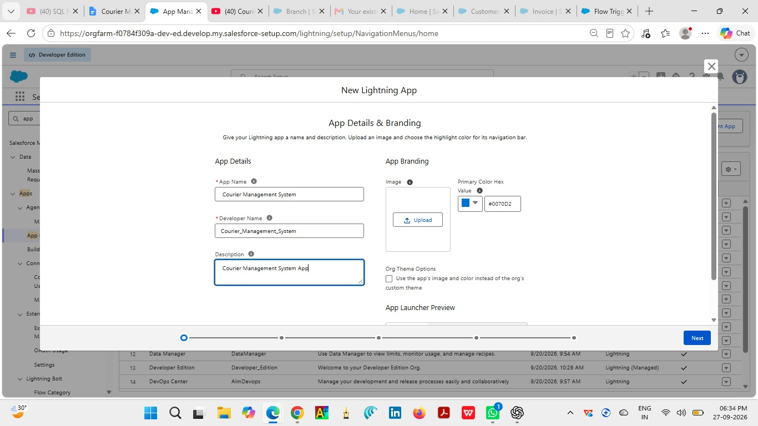

MILESTONE 8 – LIGHTNING APP

Courier Management System App
A Salesforce Lightning App provides a dedicated navigation experience for the Courier Management System. The app brings the main courier objects and reporting components into one workspace.
Navigation Item | Purpose
Customer | Customer records
Shipment | Shipment records
Delivery Agent | Agent records
Branch | Branch records
Delivery Update | Delivery updates
Invoice | Invoice records
Reports | Operational reports
Dashboards | Management dashboards

App Creation Steps
- Open Setup and App Manager.
- Select New Lightning App.
- Enter the app name Courier Management System.
- Configure navigation items in the required order.
- Set the intended user/profile access.
- Save and Finish.
- Open the app and verify the navigation.

MILESTONE 9 – PROFILE
Salesforce Profiles define baseline permissions for users. Profiles are used to control object access, tab visibility, and create/read/edit/delete capabilities according to the responsibilities of each role.

Courier Admin
Purpose: Full administrative access for managing the Courier Management System configuration and operational data.
Base / configuration reference: System Administrator
The Courier Admin profile is created by cloning the System Administrator profile and adapting access to the Courier Management System.
Permission Area | Configuration
Object Permissions | Set Read, Create, Edit, and Delete access appropriate to the profile.
Tab Visibility | Show relevant Courier Management System tabs.
Record Access | Combine profile permissions with role hierarchy and sharing behavior.
Security | Provide only the access required for the user's responsibilities.

Configuration Steps
- Open Setup and Profiles.
- Select or create the profile.
- Configure object permissions.
- Configure tab visibility.
- Review system and application permissions.

MILESTONE 9 – PROFILE
Salesforce Profiles define baseline permissions for users. Profiles are used to control object access, tab visibility, and create/read/edit/delete capabilities according to the responsibilities of each role.

Branch Manager
Purpose: Access required to manage branch-level courier operations, shipments, agents, and reporting.
Base / configuration reference: Standard Platform User
The Branch Manager profile is based on the Standard Platform User and is configured for branch-level operational visibility.
Permission Area | Configuration
Object Permissions | Set Read, Create, Edit, and Delete access appropriate to the profile.
Tab Visibility | Show relevant Courier Management System tabs.
Record Access | Combine profile permissions with role hierarchy and sharing behavior.
Security | Provide only the access required for the user's responsibilities.

Configuration Steps
- Open Setup and Profiles.
- Select or create the profile.
- Configure object permissions.
- Configure tab visibility.
- Review system and application permissions.
- Save the profile and verify access with a test user.

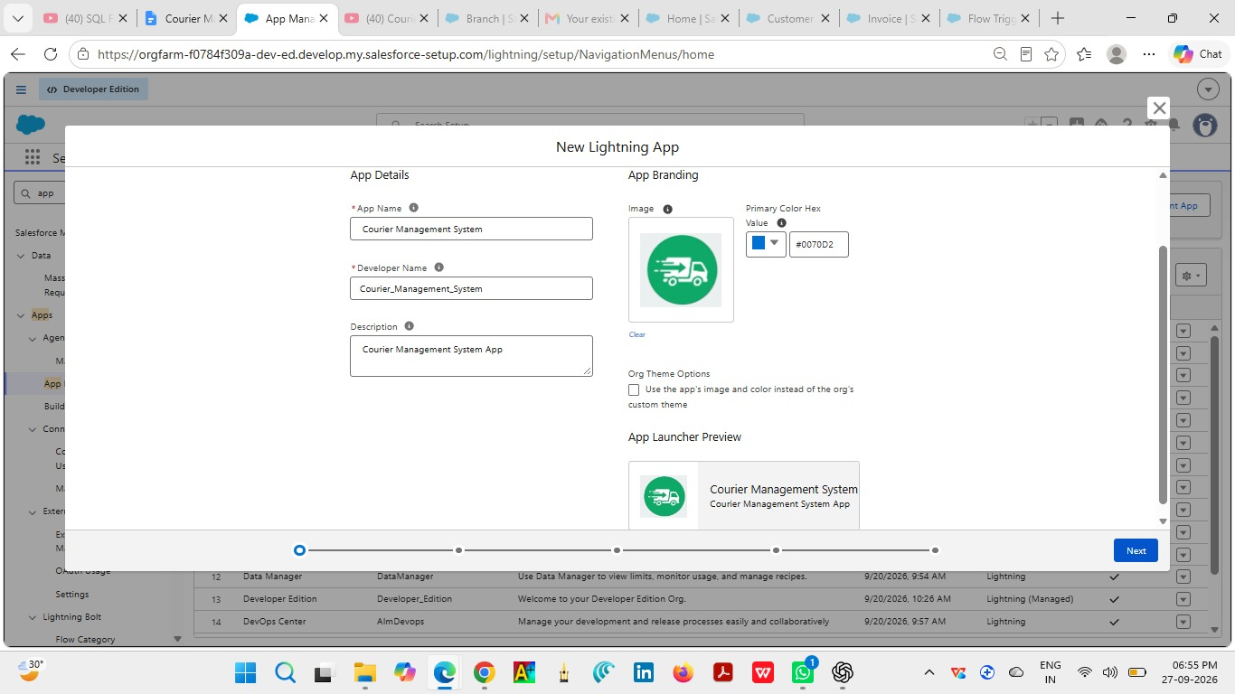
MILESTONE 9 – PROFILE
Salesforce Profiles define baseline permissions for users. Profiles are used to control object access, tab visibility, and create/read/edit/delete capabilities according to the responsibilities of each role.

Delivery Agent
Purpose: Limited access needed to work with assigned delivery activities and updates.
Base / configuration reference: Configured operational profile
Permission Area | Configuration
Object Permissions | Set Read, Create, Edit, and Delete access appropriate to the profile.
Tab Visibility | Show relevant Courier Management System tabs.
Record Access | Combine profile permissions with role hierarchy and sharing behavior.
Security | Provide only the access required for the user's responsibilities.

Configuration Steps
- Open Setup and Profiles.
- Select or create the profile.
- Configure object permissions.
- Configure tab visibility.
- Review system and application permissions.
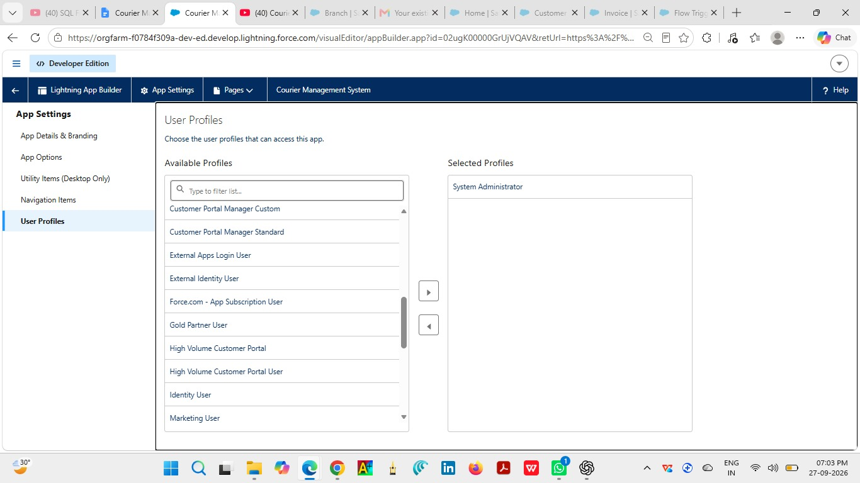
- Save the profile and verify access with a test user.

MILESTONE 9 – PROFILE
Salesforce Profiles define baseline permissions for users. Profiles are used to control object access, tab visibility, and create/read/edit/delete capabilities according to the responsibilities of each role.

Customer Support
Purpose: Access needed to view and support customer and shipment information.
Base / configuration reference: Configured support profile
Permission Area | Configuration
Object Permissions | Set Read, Create, Edit, and Delete access appropriate to the profile.
Tab Visibility | Show relevant Courier Management System tabs.
Record Access | Combine profile permissions with role hierarchy and sharing behavior.
Security | Provide only the access required for the user's responsibilities.

Configuration Steps
- Open Setup and Profiles.
- Select or create the profile.
- Configure object permissions.
- Configure tab visibility.
- Review system and application permissions.
- Save the profile and verify access with a test user.

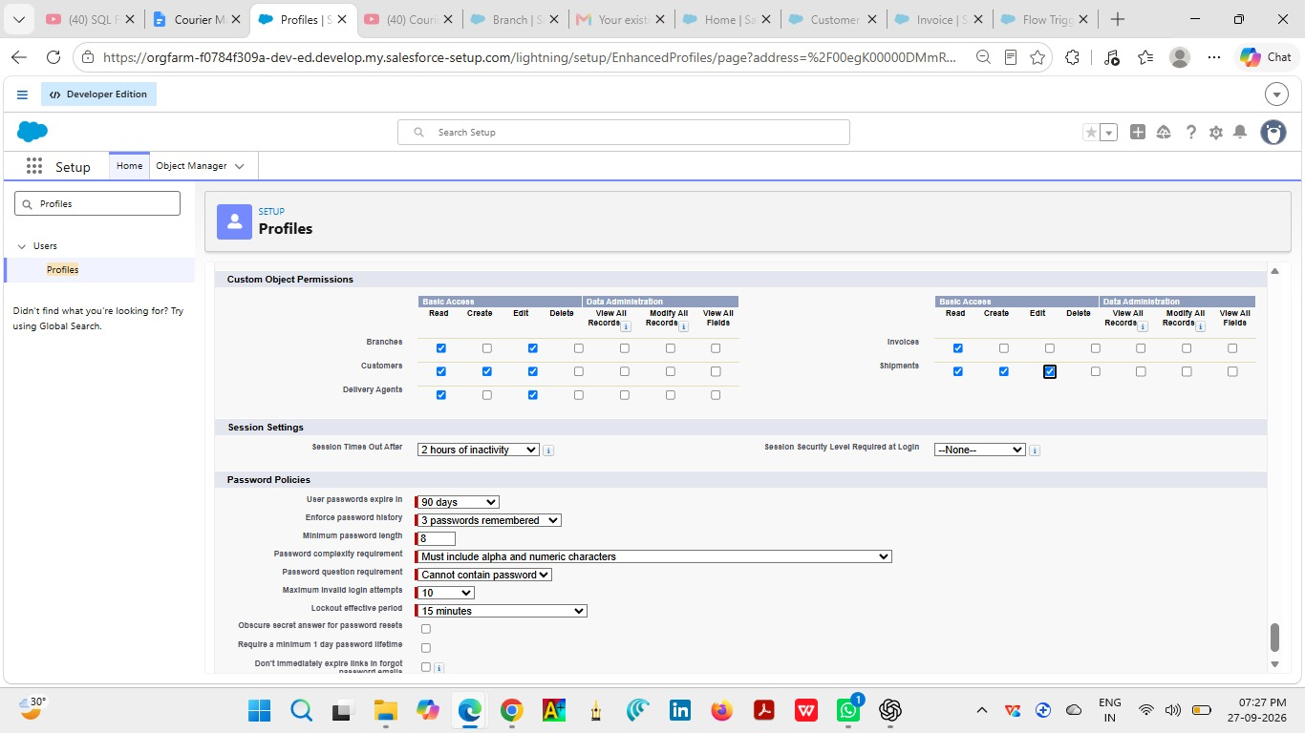
MILESTONE 9 – PROFILE
Salesforce Profiles define baseline permissions for users. Profiles are used to control object access, tab visibility, and create/read/edit/delete capabilities according to the responsibilities of each role.

Courier Admin
Purpose: Full administrative access for managing the Courier Management System configuration and operational data.
Base / configuration reference: System Administrator
The Courier Admin profile is created by cloning the System Administrator profile and adapting access to the Courier Management System.
Permission Area | Configuration
Object Permissions | Set Read, Create, Edit, and Delete access appropriate to the profile.
Tab Visibility | Show relevant Courier Management System tabs.
Record Access | Combine profile permissions with role hierarchy and sharing behavior.
Security | Provide only the access required for the user's responsibilities.

Configuration Steps
- Open Setup and Profiles.
- Select or create the profile.
- Configure object permissions.
- Configure tab visibility.
- Review system and application permissions.
- Save the profile and verify access with a test user.

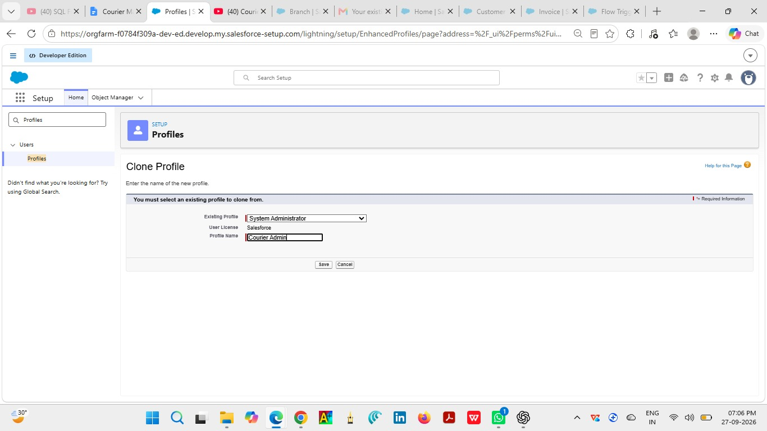
MILESTONE 9 – PROFILE
Salesforce Profiles define baseline permissions for users. Profiles are used to control object access, tab visibility, and create/read/edit/delete capabilities according to the responsibilities of each role.

Branch Manager
Purpose: Access required to manage branch-level courier operations, shipments, agents, and reporting.
Base / configuration reference: Standard Platform UseThe Branch Manager profile is based on the Standard Platform User and is configured for branch-level operational visibility.
Permission Area | Configuration
Object Permissions | Set Read, Create, Edit, and Delete access appropriate to the profile.
Tab Visibility | Show relevant Courier Management System tabs.
Record Access | Combine profile permissions with role hierarchy and sharing behavior.
Security | Provide only the access required for the user's responsibilities.

Configuration Steps
- Open Setup and Profiles.
- Select or create the profile.
- Configure object permissions.
- Configure tab visibility.
- Review system and application permissions.
- Save the profile and verify access with a test user.

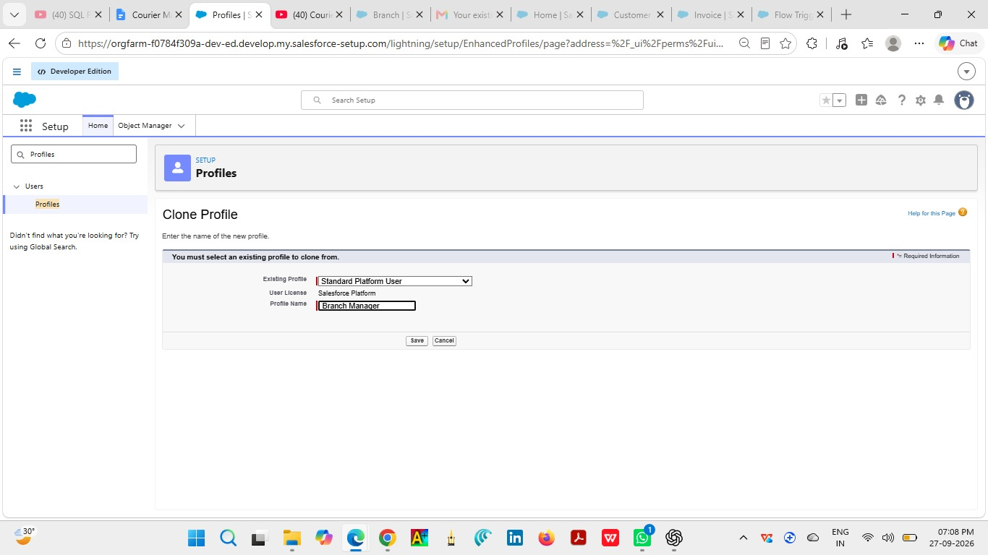
MILESTONE 9 – PROFILE
Salesforce Profiles define baseline permissions for users. Profiles are used to control object access, tab visibility, and create/read/edit/delete capabilities according to the responsibilities of each role.

Delivery Agent
Purpose: Limited access needed to work with assigned delivery activities and updates.
Base / configuration reference: Configured operational profile
Permission Area | Configuration
Object Permissions | Set Read, Create, Edit, and Delete access appropriate to the profile.
Tab Visibility | Show relevant Courier Management System tabs.
Record Access | Combine profile permissions with role hierarchy and sharing behavior.
Security | Provide only the access required for the user's responsibilities.

Configuration Steps
- Open Setup and Profiles.
- Select or create the profile.
- Configure object permissions.
- Configure tab visibility.
- Review system and application permissions.
- Save the profile and verify access with a test user.

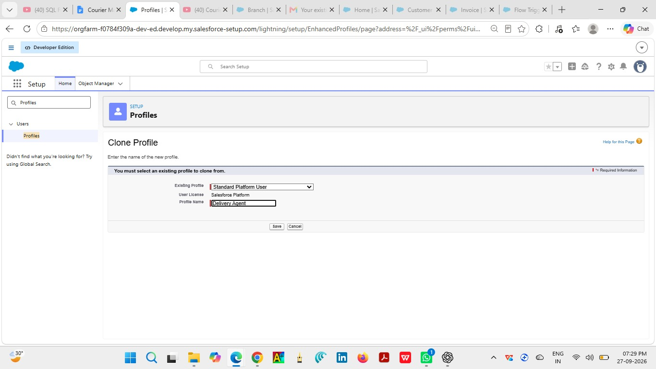

MILESTONE 10 – ROLE

Salesforce Role Hierarchy
The role hierarchy organizes users according to their operational responsibilities and supports record visibility. The Courier Management System uses the following hierarchy.
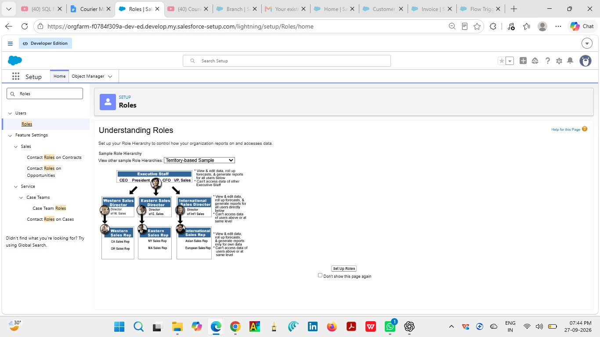
Role | Reports To | Purpose
Courier Admin | Top level | Administrative oversight.
Branch Manager | Courier Admin | Branch-level operational management.
Delivery Agent | Branch Manager | Delivery activities.
Customer Support | Branch Manager | Customer and shipment support.

Purpose of the Hierarchy
- Organizes operational responsibility.
- Supports record visibility according to role structure.
- Separates administrative and operational responsibilities.
- Provides a clear organizational model for users.
Milestone 11- User :
What is a user?
A user is anyone who logs in to Salesforce. Users are employees at your company, such as sales,reps, managers, and IT specialists, who need access to the company's records. Every user in Salesforce has a user account. The user account identifies the user, and the user account settings determine what features and records the user can access.
NOTE- As Salesforce license can only be used by 2 Users at a time in Dev Org, So If you don’t find a salesforce license then deactivate a user who has a salesforce license Or change the license type from Salesforce to any other.
Activity 1: To Create a User
Steps:
1. From Setup, enter Users in the Quick Find box, then select Users.
2. Click New User.

Fill in the Fields: Field Name | Value
First Name | Enter first name (Example: Ravi)
Last Name | Enter last name (Example: Kumar)

3. click save.
The Salesforce Developer Org has user/license limitations. The project should therefore create only the users needed for configuration and testing within the available environment.

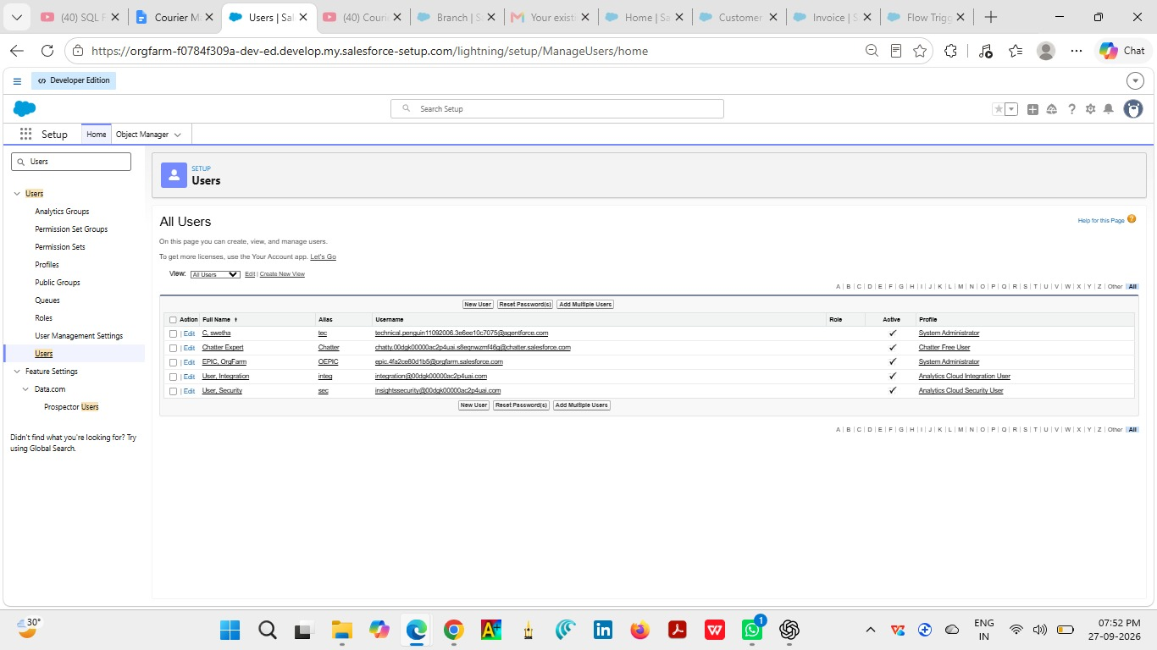
Alias | Give an alias name
Email ID | Enter your personal email ID
Username | Must be in the format: text@text.text and must be unique
Nickname | Give a nickname
Role | Select Courier Admin
User License | Salesforce
Profile | Courier Admin

MILESTONE 15 – REPORTS & DASHBOARDS

Shipment Status Summary
The Shipment Status Summary is designed to summarize a specific area of courier operations. Configure the report using the appropriate Salesforce report type, fields, filters, and grouping.

Creation Steps
- Open Reports and select New Report.
- Choose the appropriate report type.
- Add the fields required for the report.
- Configure filters for the relevant records.
- Group the report according to the required analysis.
- Select an appropriate chart when applicable.
- Save the report with the required name.
- Run the report and verify the results.
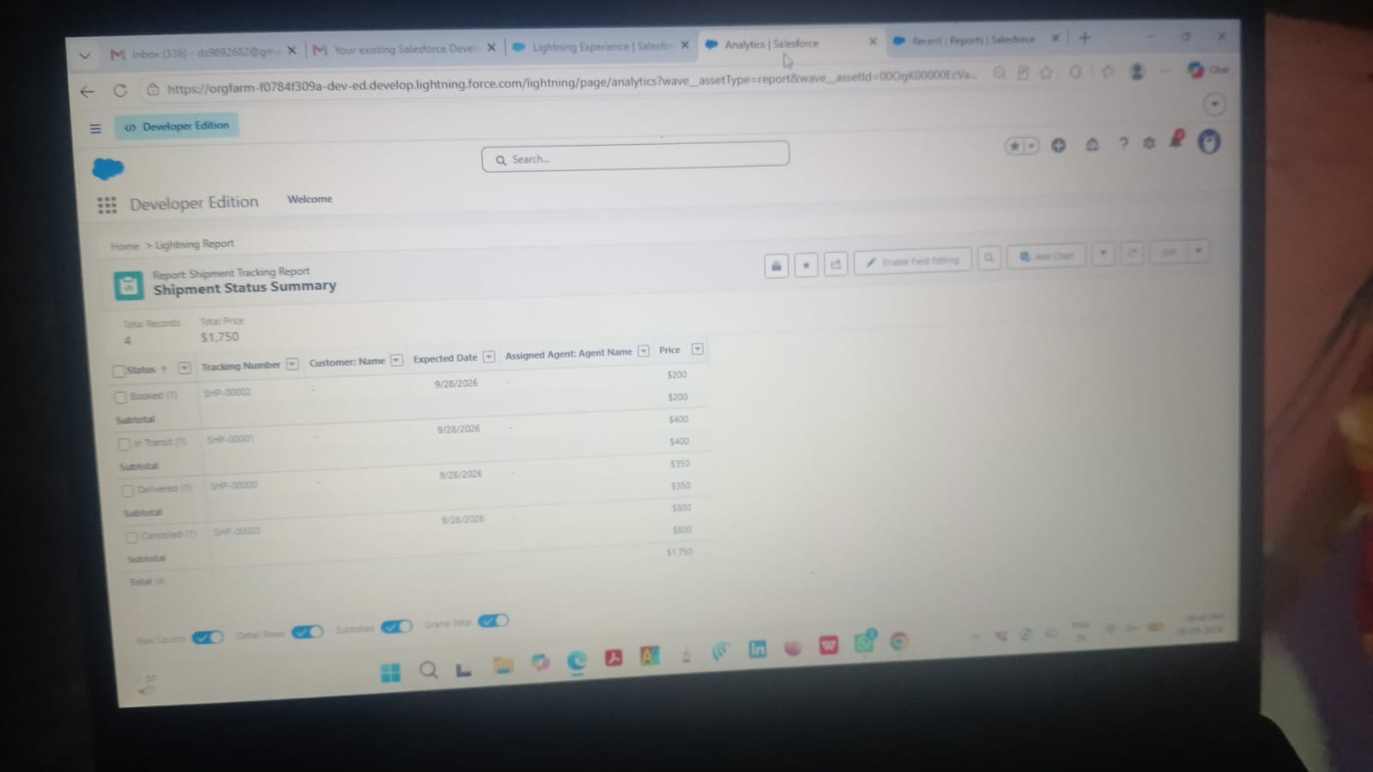

Milestone 15 : Reports & Dashboards
Reports and Dashboards help analyze business data and track courier operations efficiently.
Activity 1: Create Report Types
Step 1: Open Report Types
1. Click Gear Icon → Select Setup.
2. In Quick Find search Report Types.
3. Click New Custom Report Type.

Step 2: Create Shipment Report Type
● Primary Object: Shipment__c
● Label: Shipment Tracking Report
● Category: Reports
● Deployment Status: Deployed
● Click Next → Save

Step 3: Create Customer Report Type
● Primary Object: Customer__c
● Label: Customer Summary Report
● Category: Reports
● Deployment Status: Deployed
● Click Next → Save

Step 4: Create Agent Performance Report Type
● Primary Object: Delivery_Agent__c
● Label: Agent Performance Report
● Category: Reports
● Deployment Status: Deployed
● Click Next → Save

Activity 2: Create Reports
Report 1: Shipment Status Summary Report
Step 1: Create the Report
1. Click App Launcher (9 dots) → Search Reports
2. Click New Report
3. Choose Shipment Tracking Report
4. Click Continue

Step 2: Add Columns
Add these fields:
● Tracking
● Expected Date
● Assigned Agent
Step 3: Add Filters
● Show Me: All Shipments
● Date Filter: This Month
● Status Filter: Select specific Status (Optional)

Step 4: Group & Summarize
● Group rows by Status__c
● Add summary on Price

Step 5: Save Report
● Click Save & Run
● Name: Shipment Status Summary
● Folder: CMS Reports

Report 2: Agent Performance Report
Step 1: Create Report
● New Report → Choose Agent Performance Report
● Click Continue

Step 2: Add Columns
● Agent Name
● Branch
● Number of Shipments
● Status

Step 3: Group Data
● Group by Delivery_Agent__c

Step 4: Save Report
● Name: Agent Performance Report
● Folder: CMS Reports
● Save & Run

Report 3: Revenue Report
Steps
● Create report using Shipment Tracking Report Type

Add fields:
● Tracking Number
● Customer
● Price
● Invoice Status

Group by:
● Branch
● Month
Save as: Revenue by Branch Report
Activity 3: Create Dashboard
Step 1: Open Dashboards
1. Click App Launcher (9 dots)
2. Search Dashboards
3. Click New Dashboard

Step 2: Enter Dashboard Details
● Name: Courier Management Dashboard
● Folder: CMS Reports
● Click Create

Activity 4: Add Dashboard Components Component 1: Shipment Status Overview (Donut Chart)
1. Click + Component
2. Choose report: Shipment Status Summary
3. Visual Type: Donut Chart
4. Click Add

Component 2: Agent Performance (Bar Chart)
● Select report: Agent Performance Report

● Chart Type: Bar Chart
● Click Add

Component 3: Revenue by Branch (Column Chart)
● Choose report: Revenue by Branch Report
● Chart Type: Column Chart
● Click Add

Activity 5: Save & Activate Dashboard
1. Click Save
2. Click Done

Share Dashboard With:
● Courier Admin
● Branch Managers
● Customer Support Team

FINAL LAYOUT
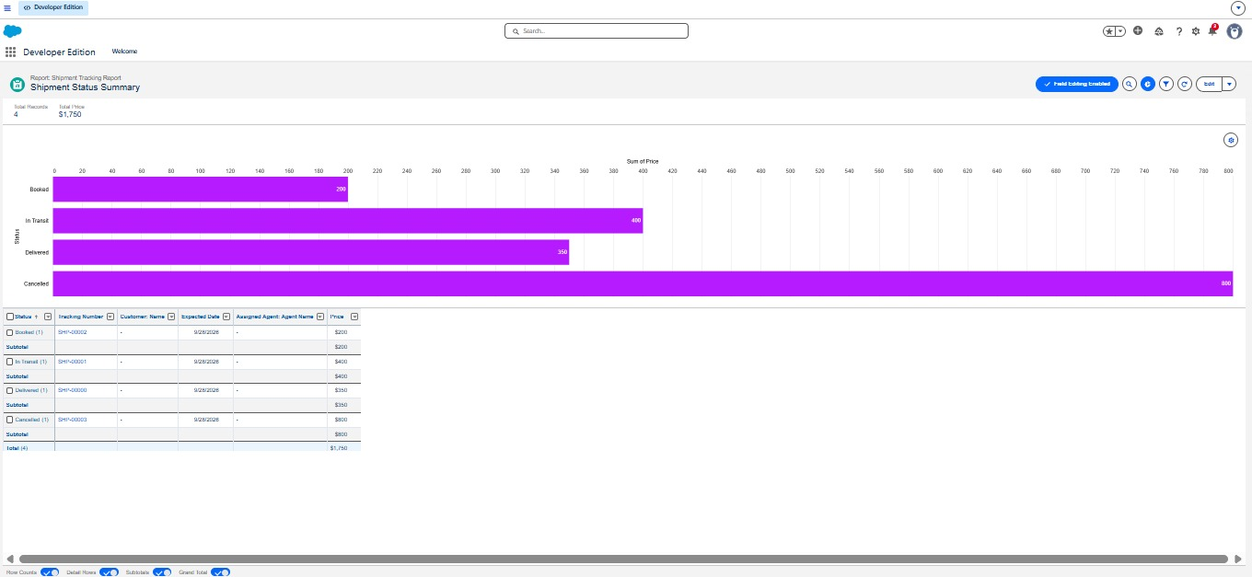
Shipment status summary

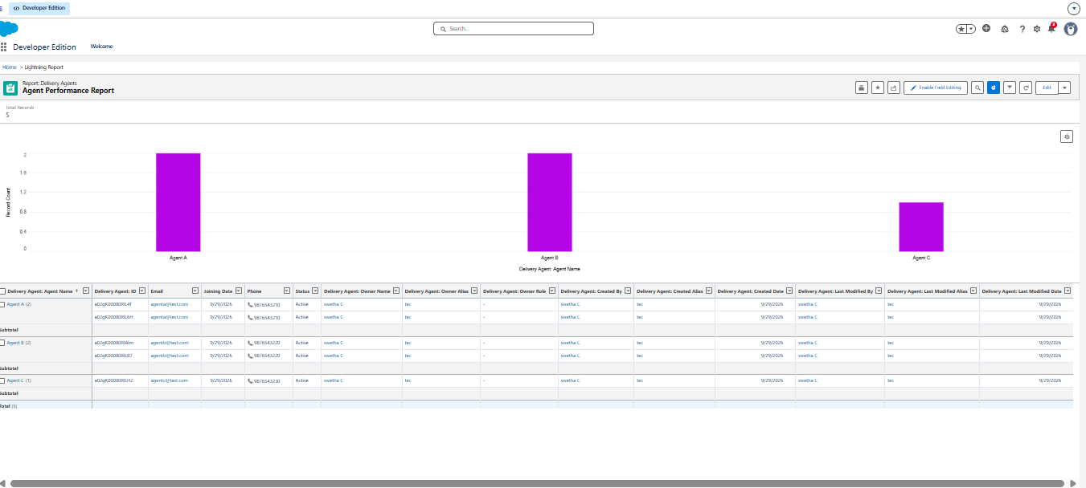

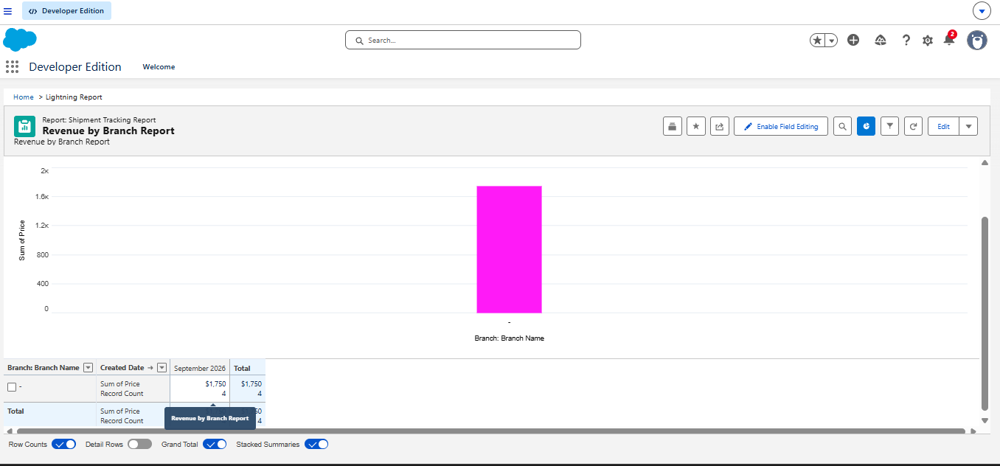
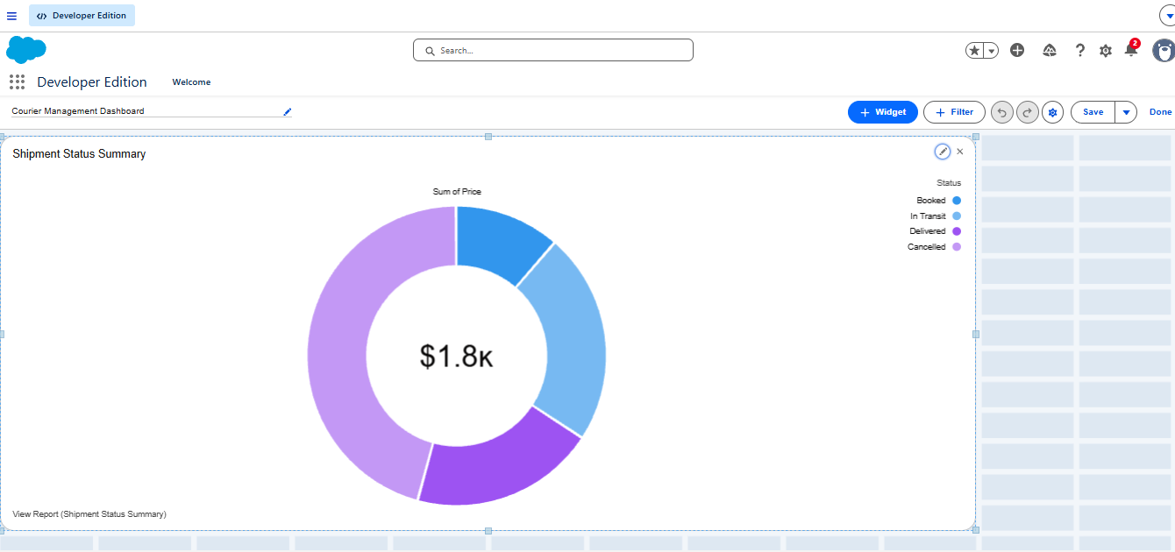

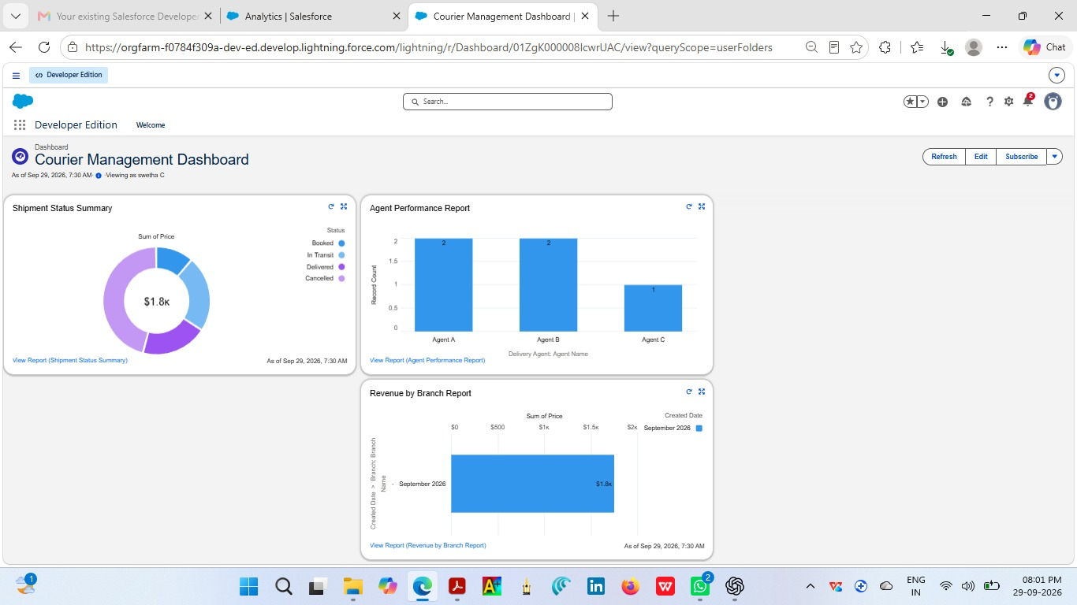
7. FUNCTIONAL & PERFORMANCE TESTING
Testing verifies that the configured Courier Management System behaves as expected. The testing focus includes record creation, validation rules, delivery status updates, Flow automation, invoice generation, and dashboard visualization.
Test Case ID | Test Scenario | Input | Expected Result | Actual Result | Status
TC-01 | Customer record creation | Valid customer data | Customer record is created successfully | Record created | Pass
TC-02 | Customer email validation | Blank email | Validation error is displayed | Error displayed | Pass
TC-03 | Phone validation | Phone length not equal to 10 | Validation error is displayed | Error displayed | Pass
TC-04 | Shipment weight validation | Weight <= 0 | Validation error is displayed | Error displayed | Pass
TC-05 | Shipment price validation | Price <= 0 | Validation error is displayed | Error displayed | Pass
TC-06 | Expected date validation | Past date | Validation error is displayed | Error displayed | Pass
TC-07 | Delivery update | Valid status update | Delivery update is saved | Saved | Pass
TC-08 | Flow automation | New Delivery_Update__c | Related shipment status changes | Status updated | Pass
TC-09 | Delayed update | Delayed status without remarks | Validation error is displayed | Error displayed | Pass
TC-10 | Invoice record | Valid invoice data | Invoice record is saved | Saved | Pass
TC-11 | Dashboard | Configured report data | Dashboard components display | Displayed | Pass

8. ADVANTAGES & DISADVANTAGES

Advantages
- Centralized data: customer, shipment, agent, branch, update, and invoice information is maintained within a common platform.
- Automated workflows: Flow can automatically synchronize shipment status from delivery updates.
- Real-time reporting: reports and dashboards provide management visibility into configured operational data.

Disadvantages
- Salesforce dependency: the system depends on the Salesforce environment and its configuration model.
- Initial configuration effort: objects, fields, relationships, rules, automation, security, reports, and dashboards require configuration.

9. CONCLUSION
The Courier Management System digitizes courier operations using Salesforce automation. The design brings shipment information, customer data, delivery-agent records, branch information, delivery updates, and invoice information into a centralized environment. Validation rules support data quality, Flow supports status automation, profiles and roles organize access, and reports and dashboards provide business visibility.
The resulting system supports operational efficiency, accuracy, customer satisfaction, and management insight by replacing disconnected processes with a structured Salesforce-based workflow.

10. FUTURE SCOPE
- Mobile tracking application
- GPS integration
- SMS notifications
- AI-based delivery optimization

11. APPENDIX
- Source Code / Salesforce Configuration
- Dataset / Salesforce Objects
- GitHub / Demo Salesforce Developer Org

THANK YOU
Courier Management System (CMS)
Salesforce-Based Courier Operations Management

